**In Class: Jenkins Tour**

*Aarsh Sheth || Pooja Sindham || Shivani Jariwala || Aishwarya Indi*

**Step 1: Creating pipeline**

Install *docker* plugin  
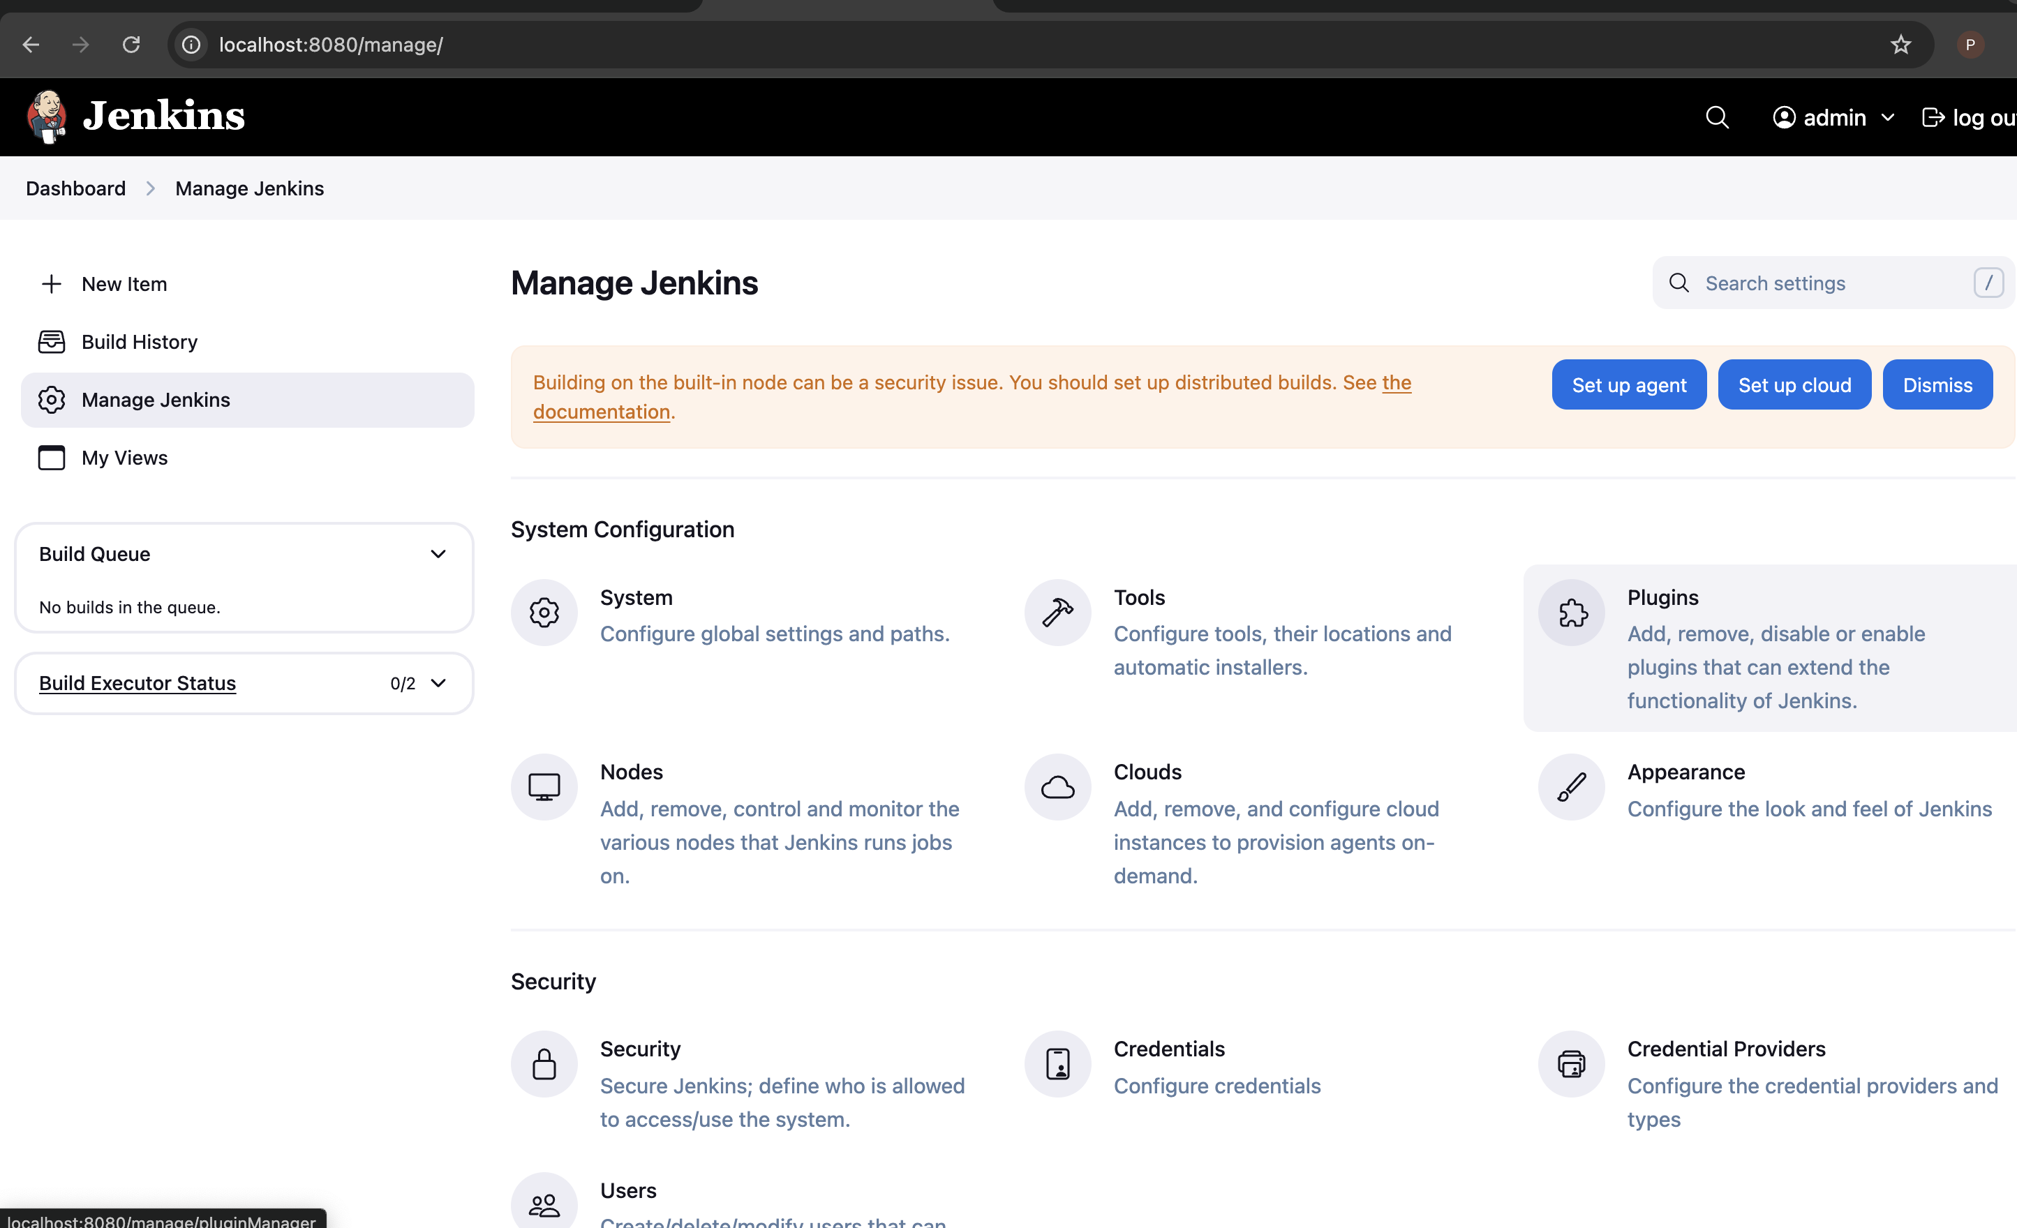

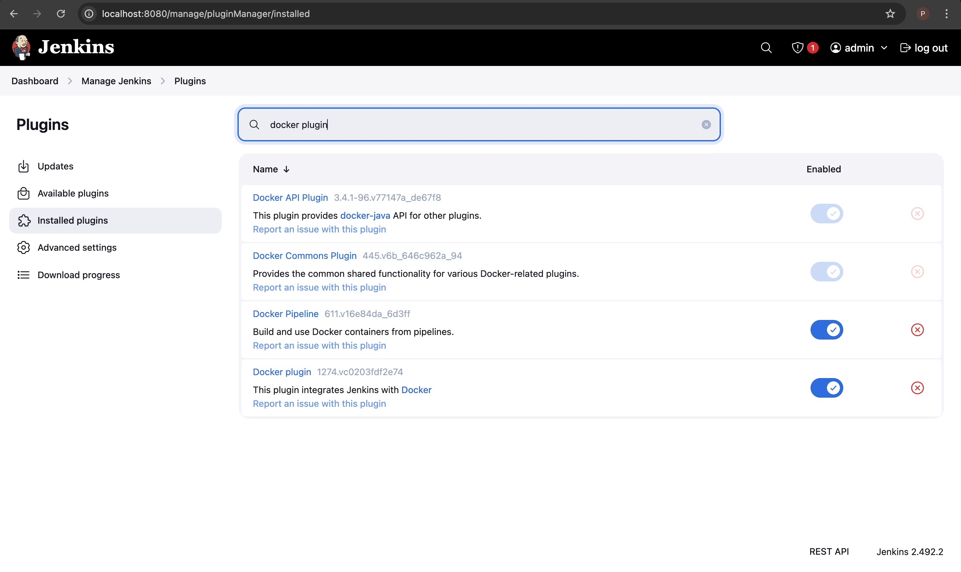

Create *JenkinFile* and upload to repo.

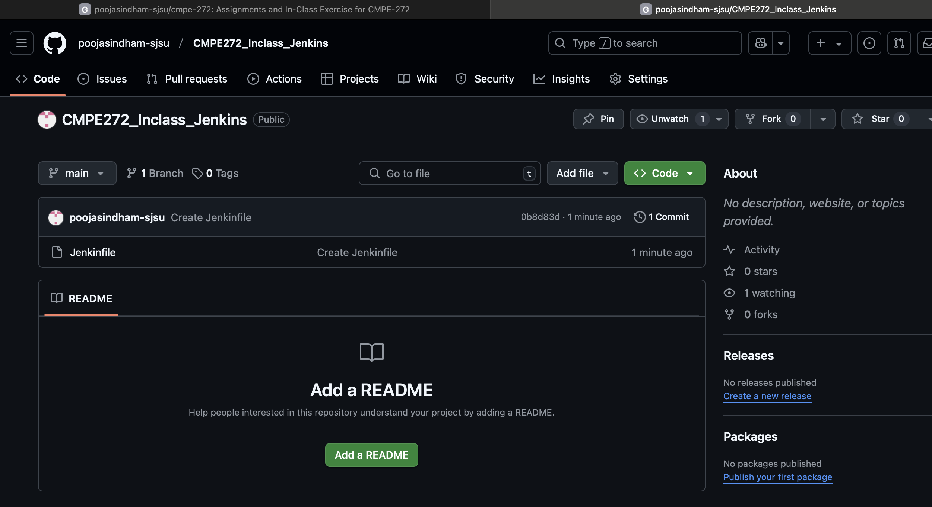

Create new item.

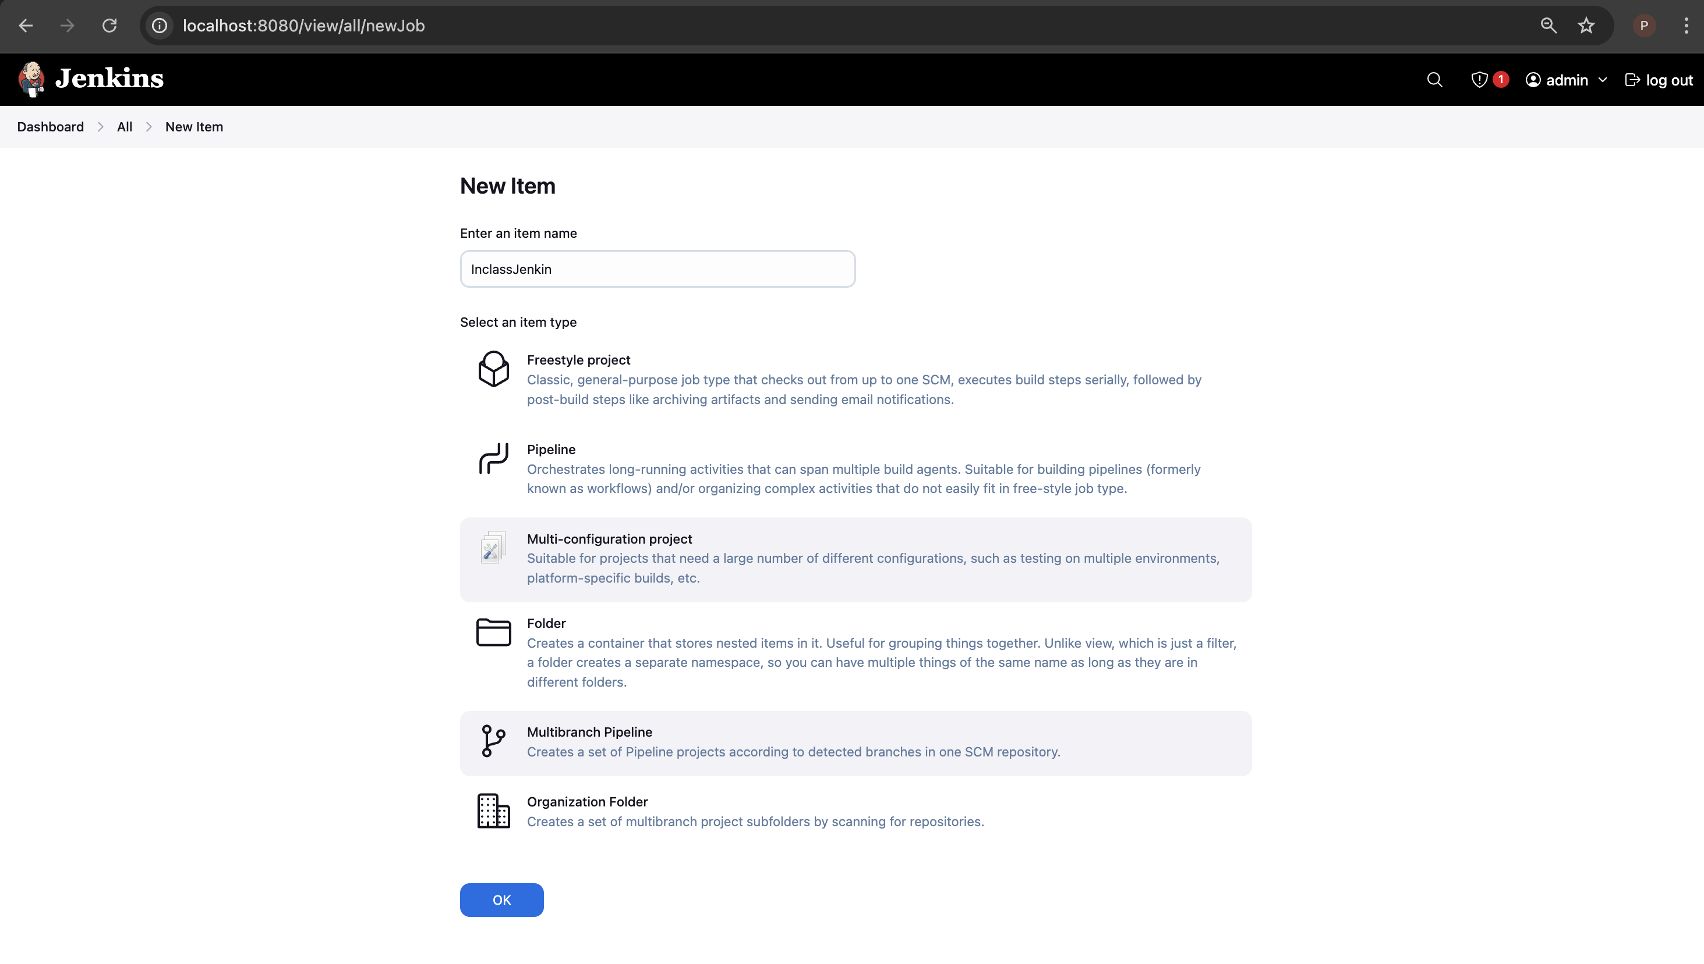

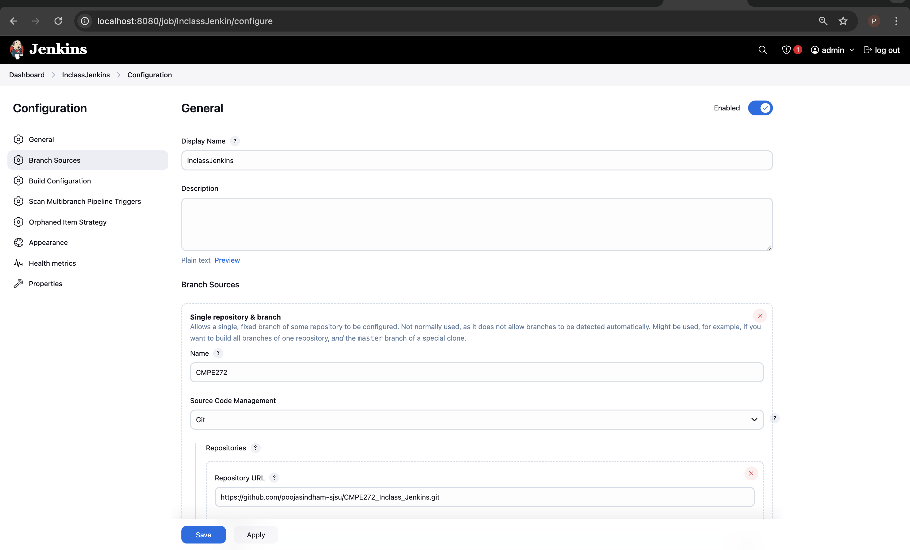

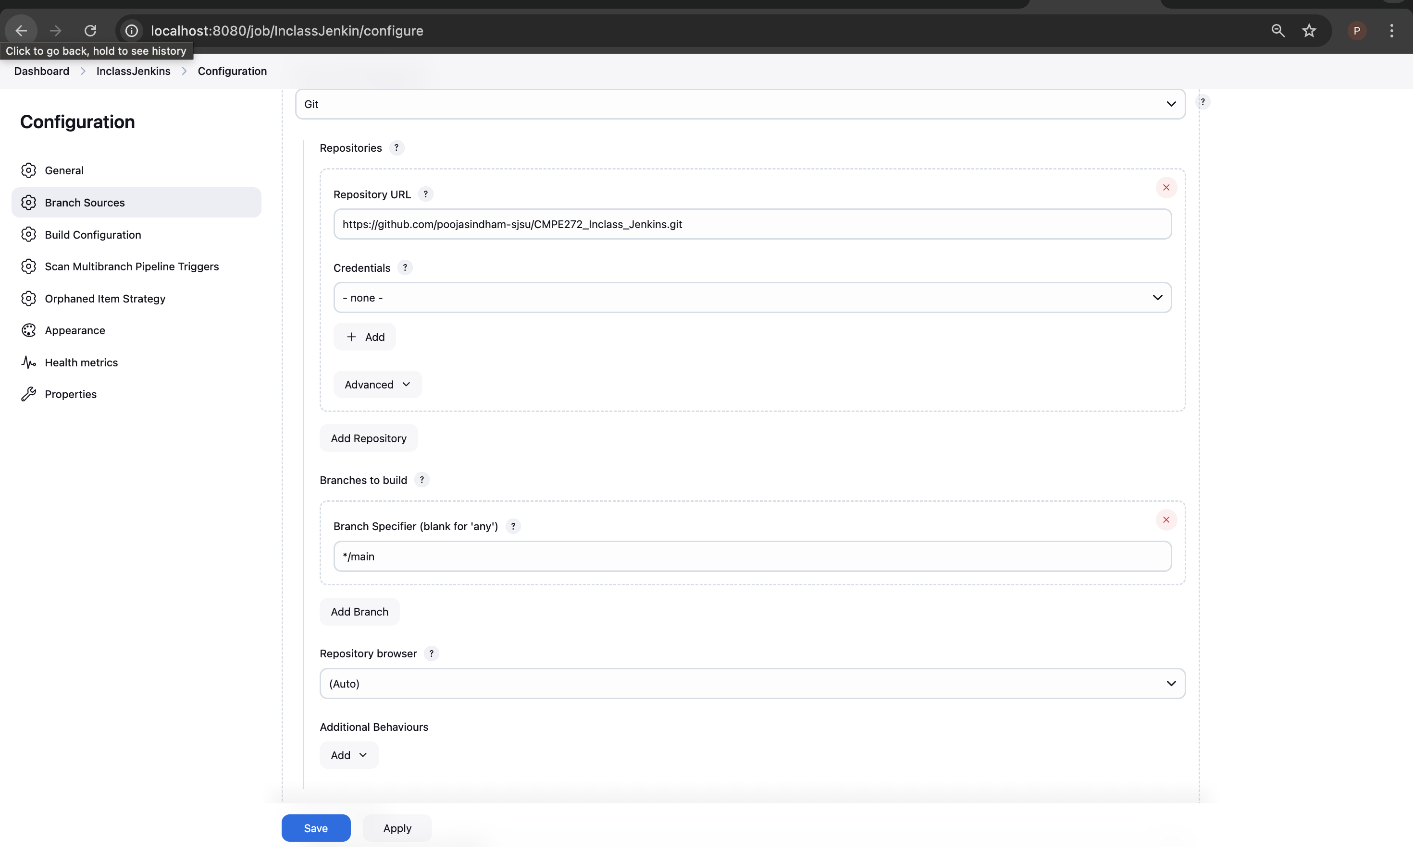

First pipeline ran successfully.

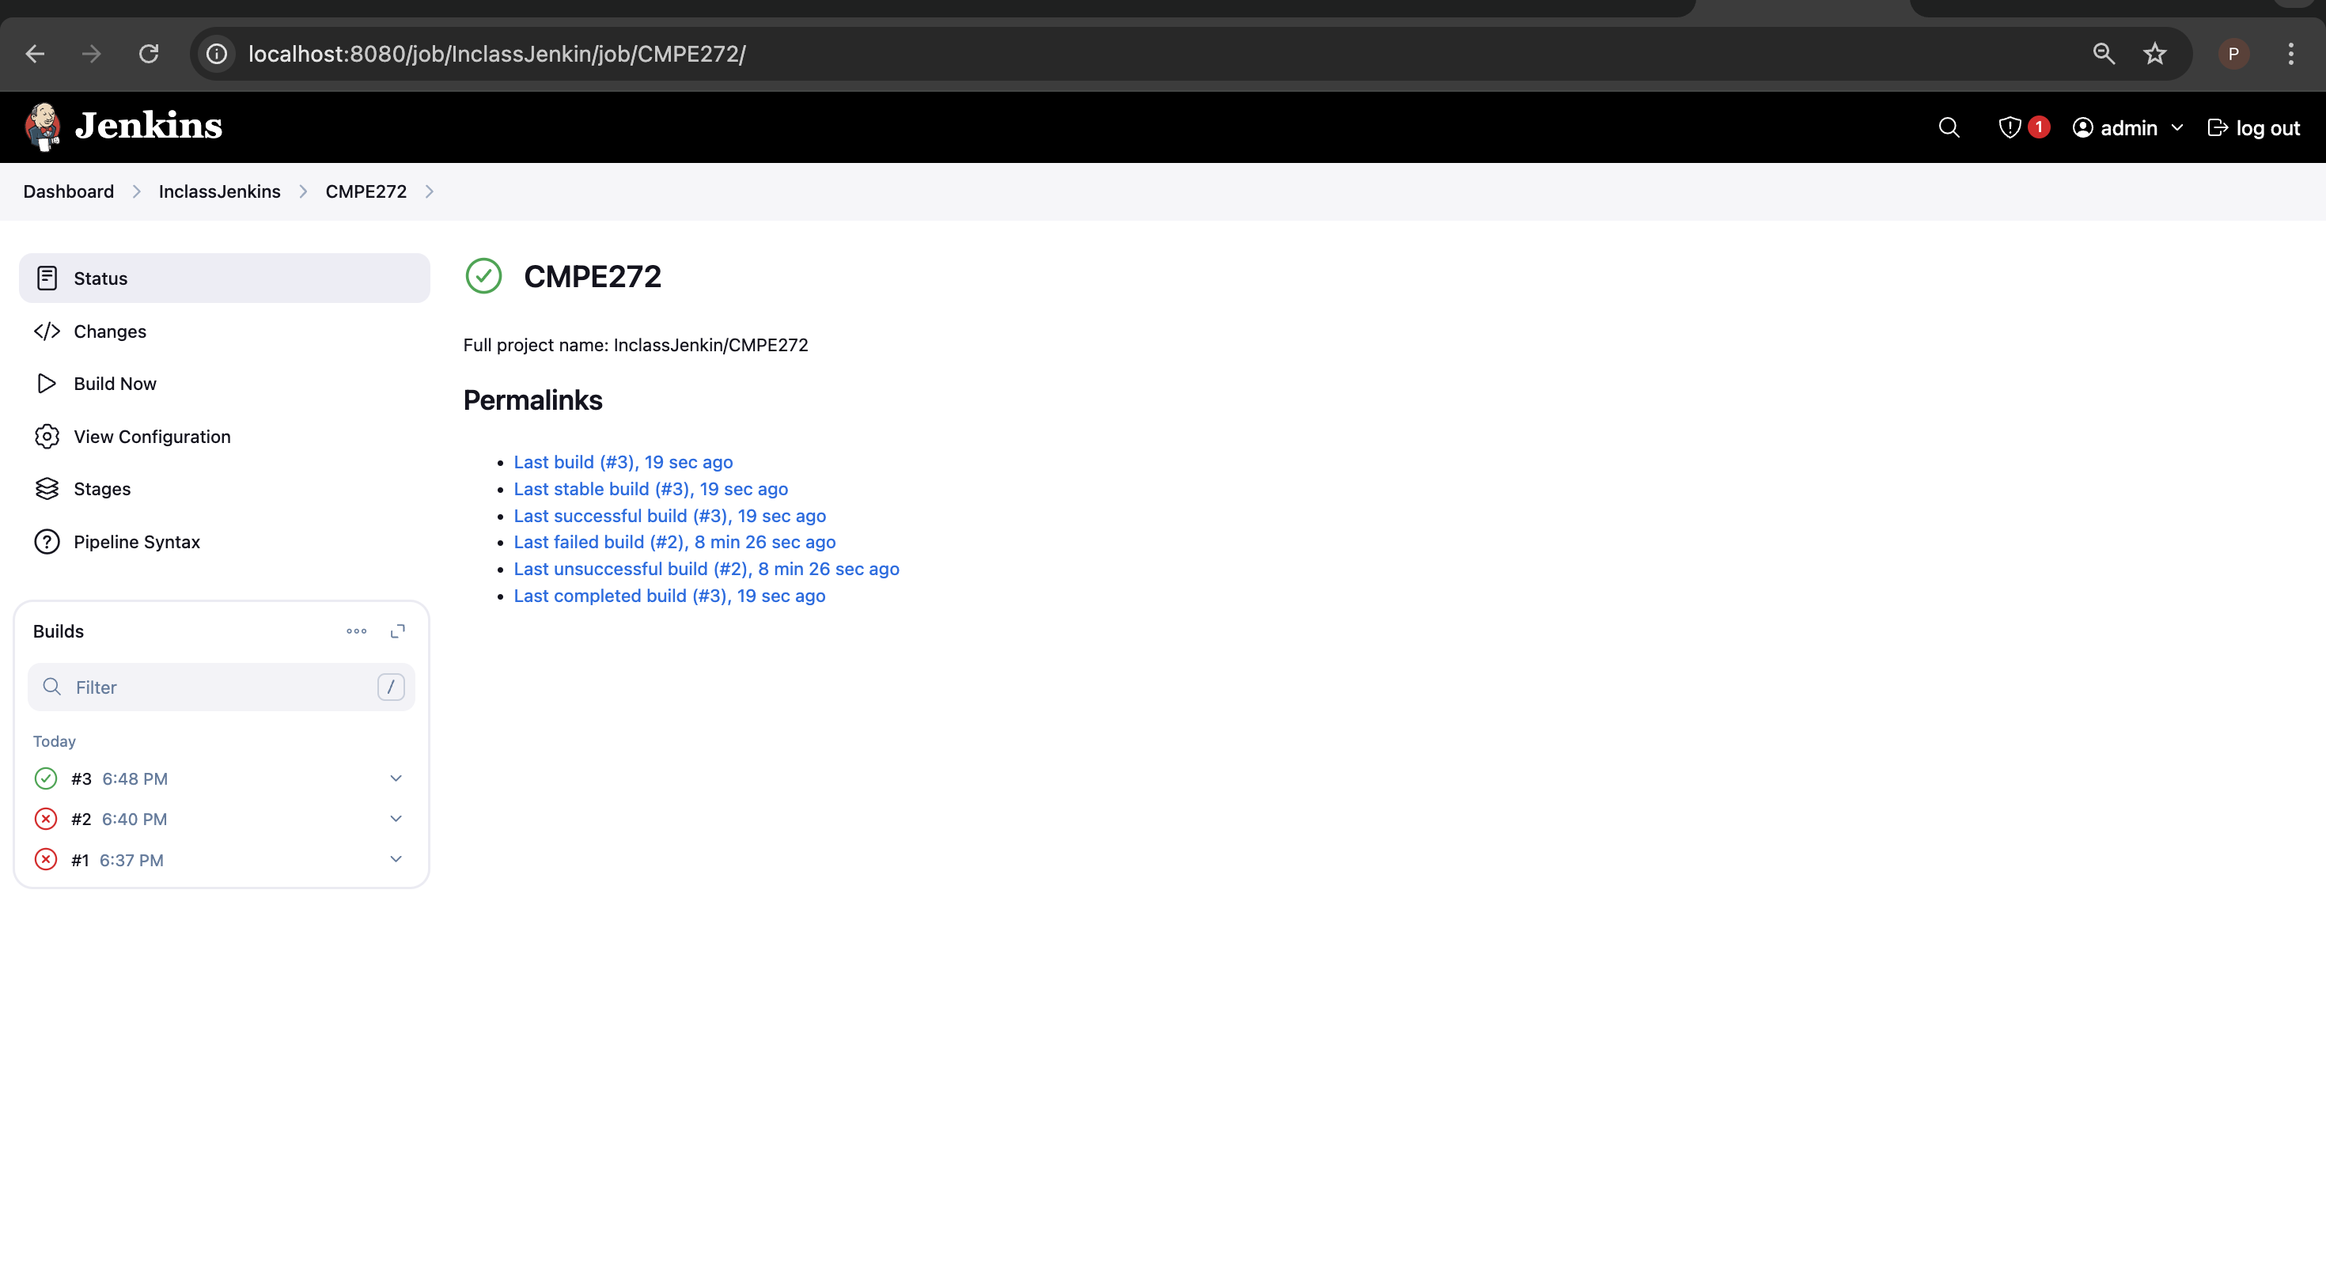

**Step 2: Running multiple pipelines**

Created two files *flakey-deploy.sh* and *health-check.sh* just for simulation.

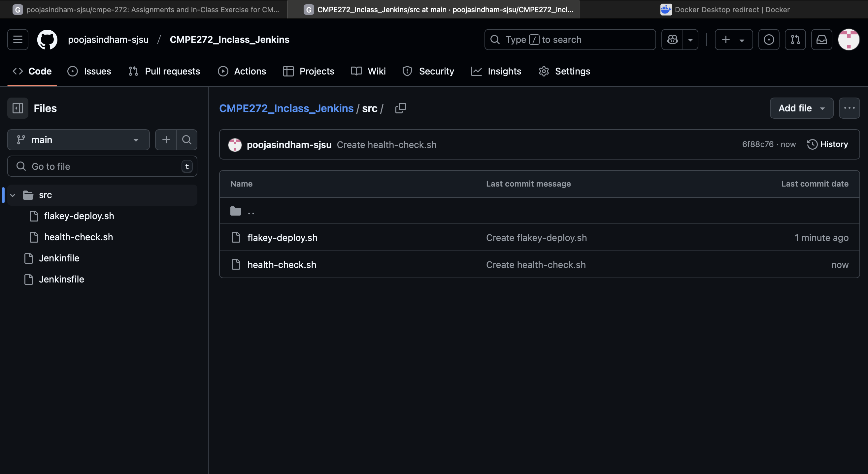

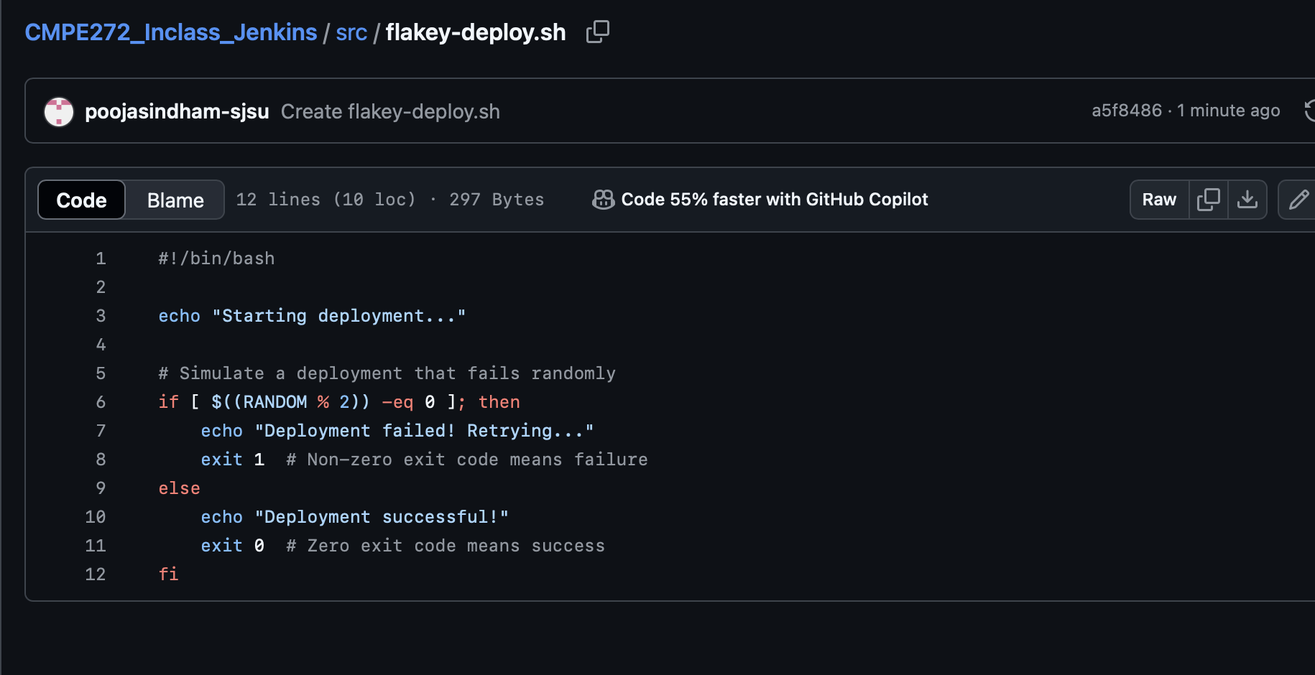

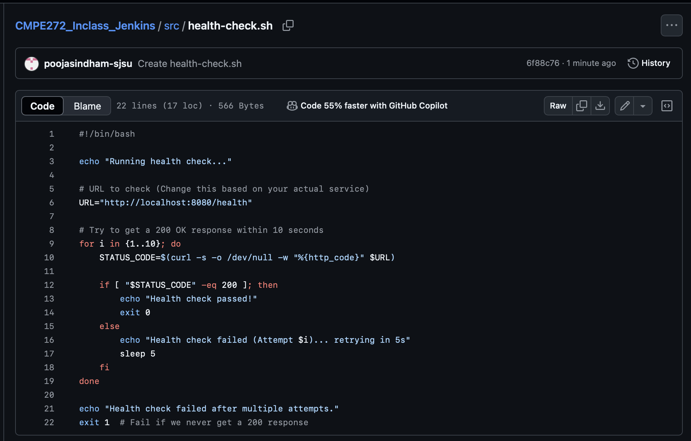

Updated *JenkinsFile*  
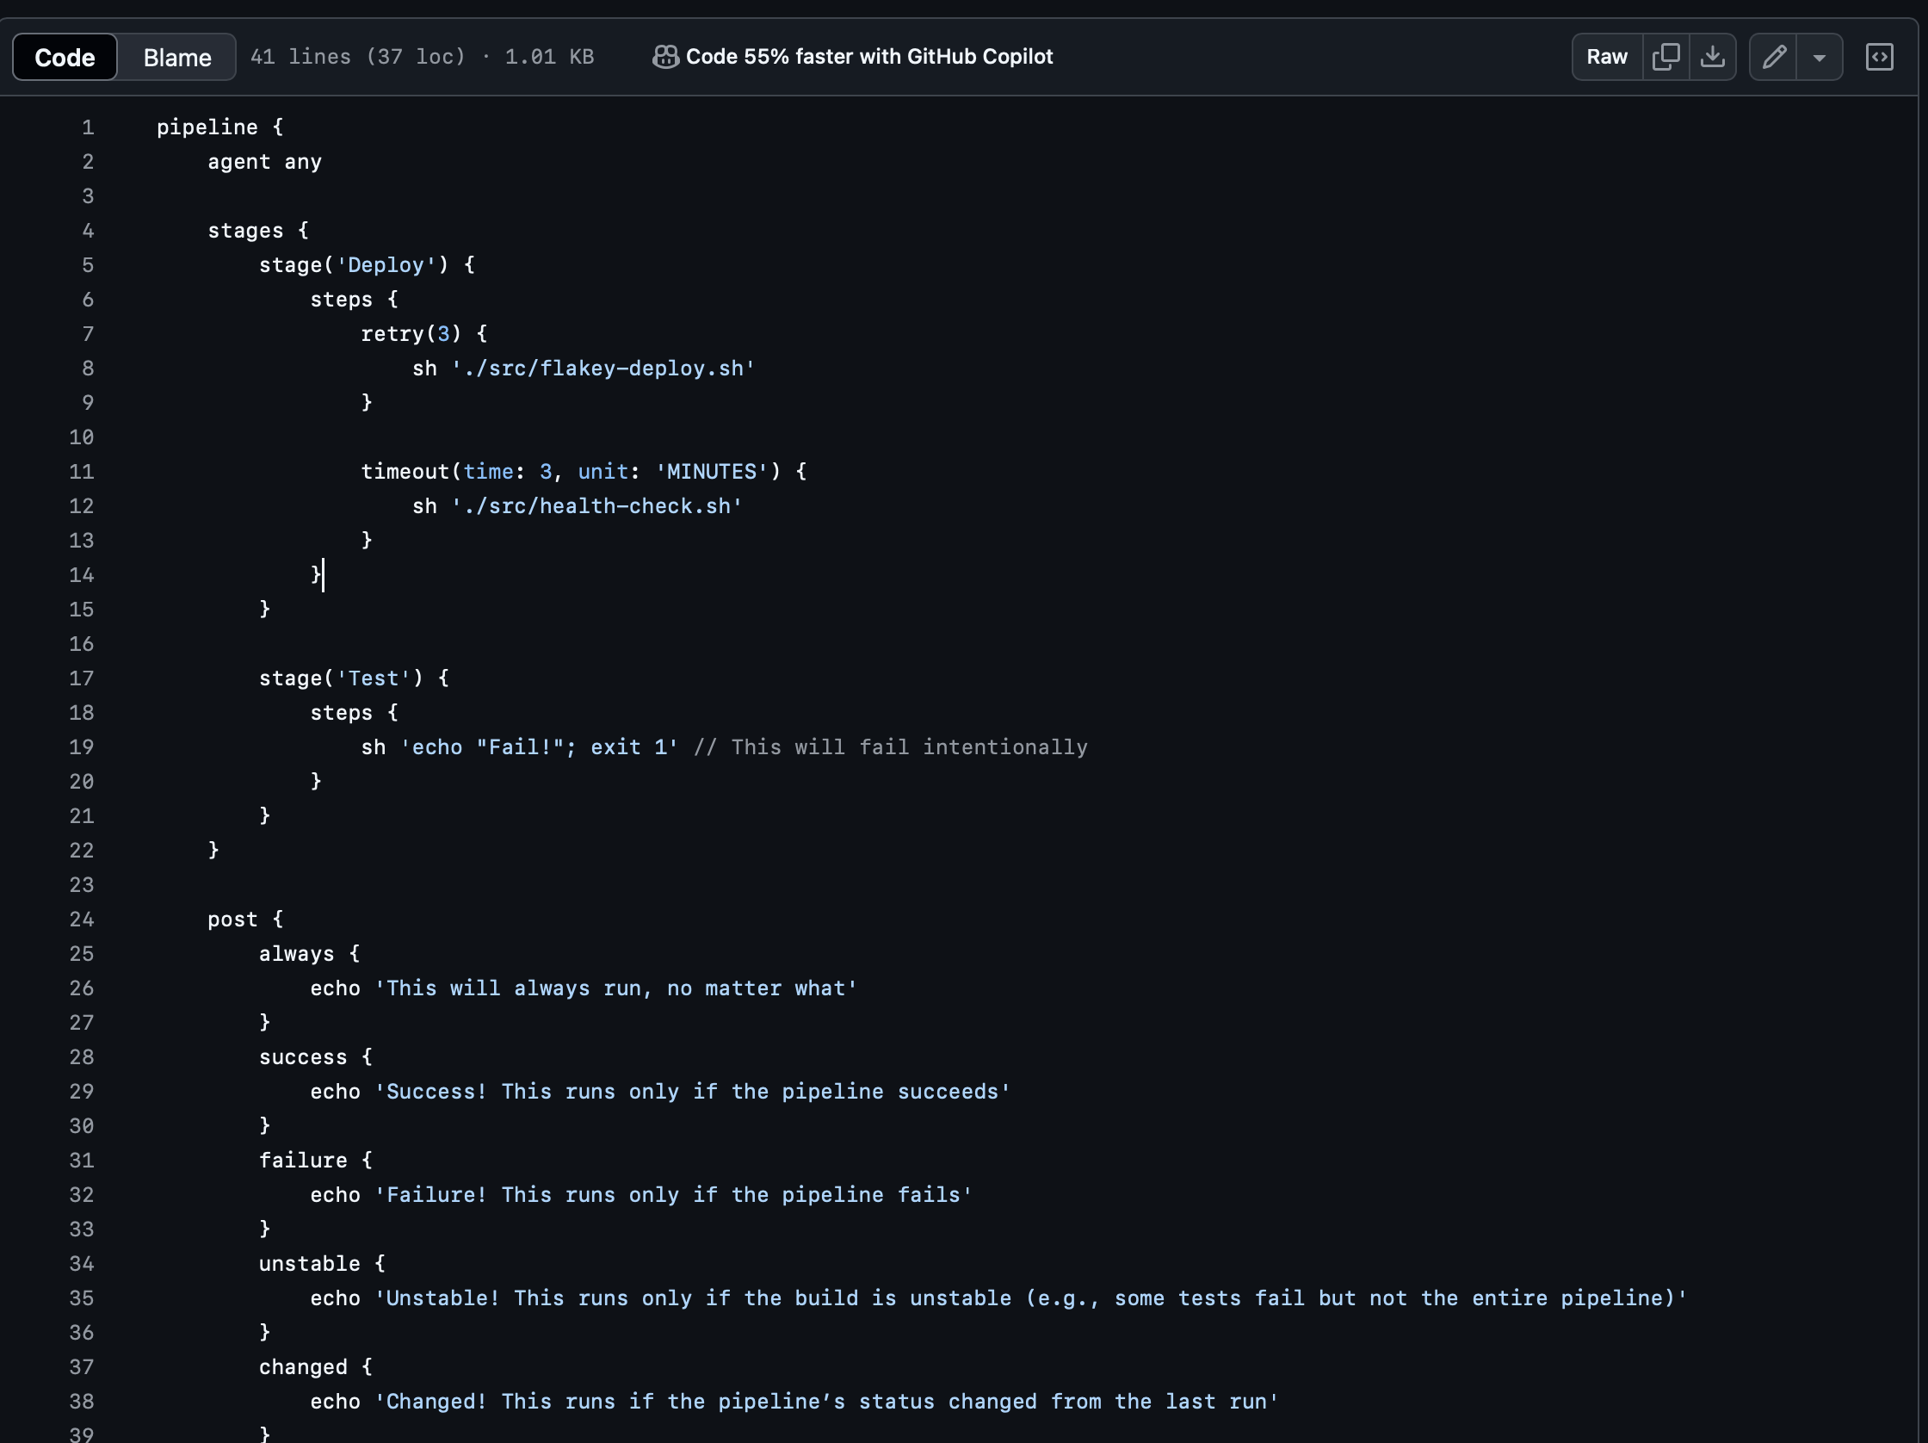

Got the following error.  
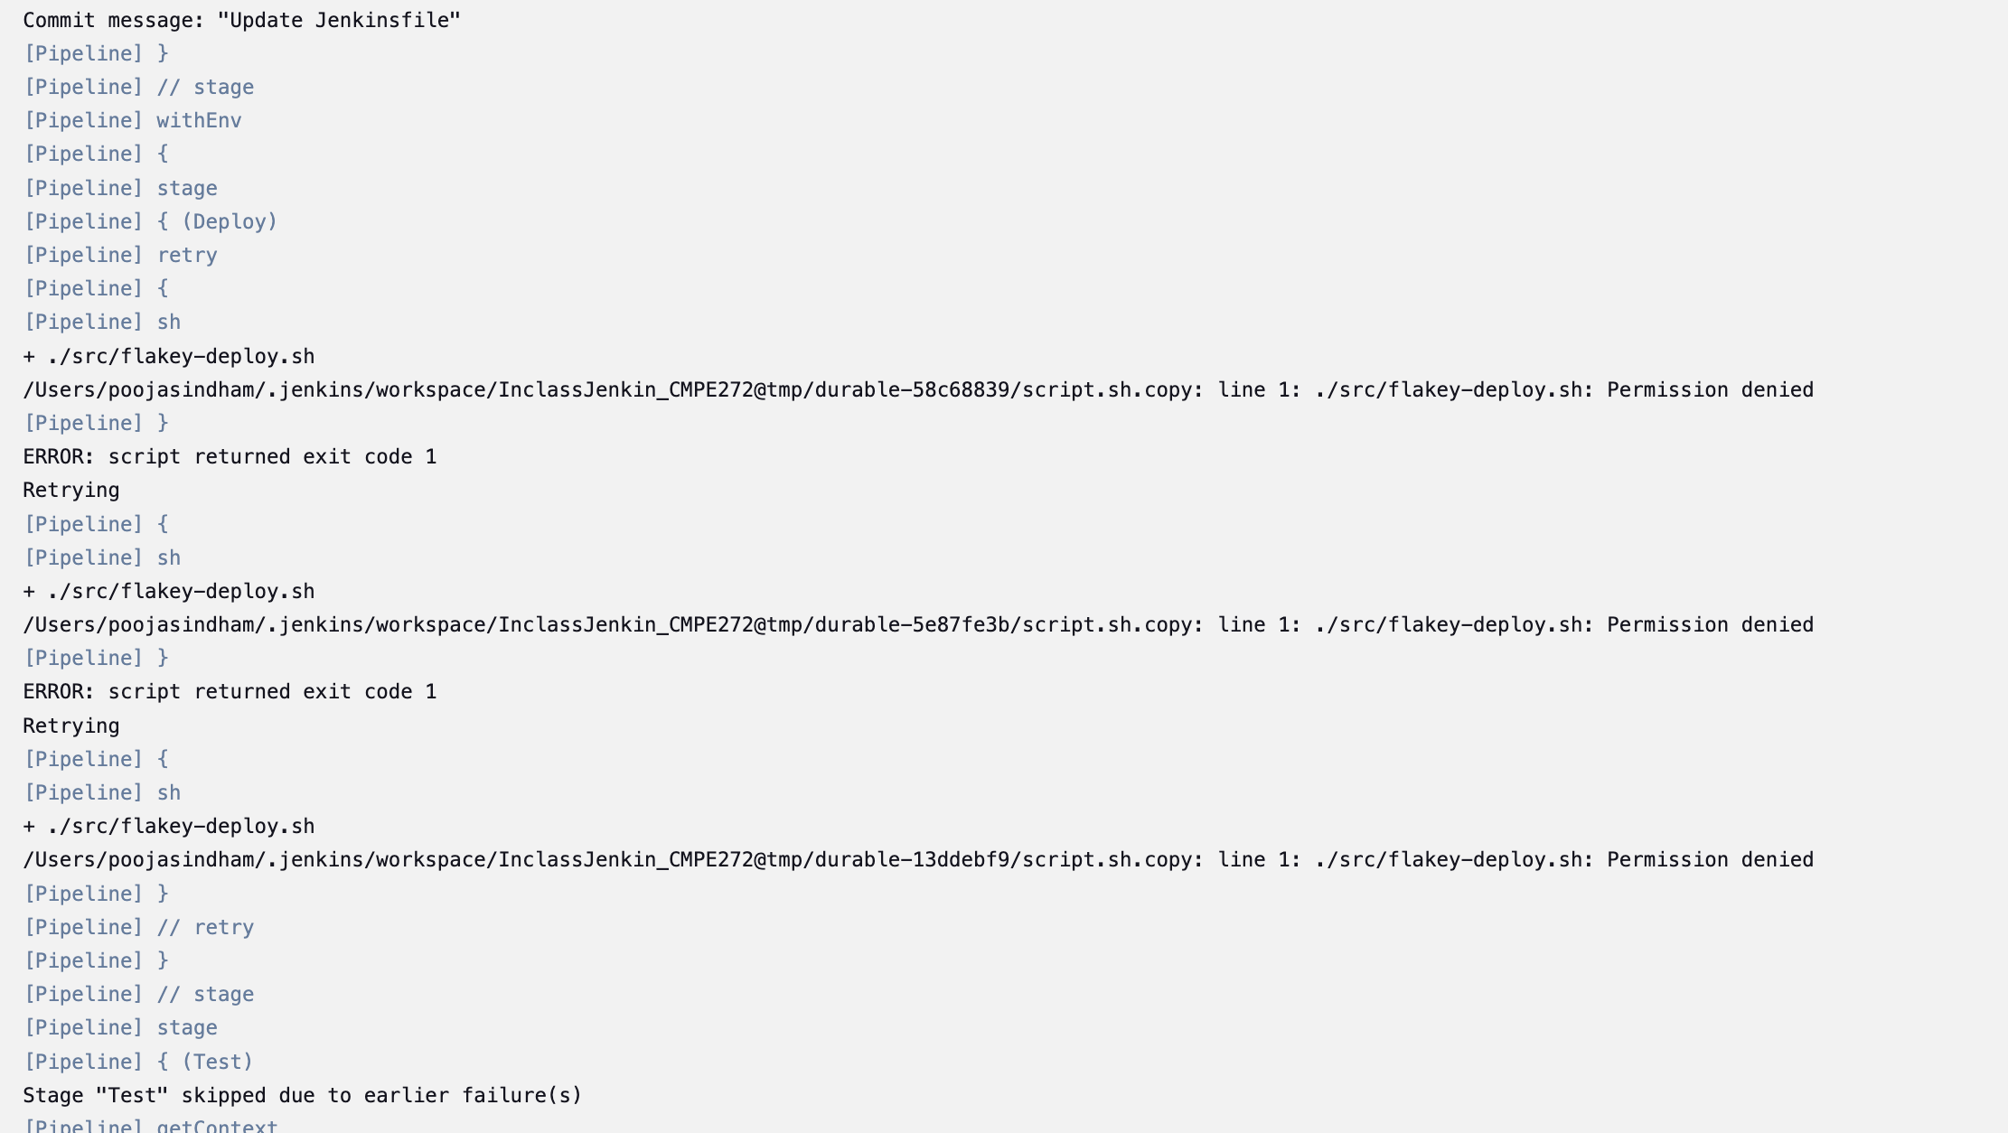

Adding one more step of adding permissions.  
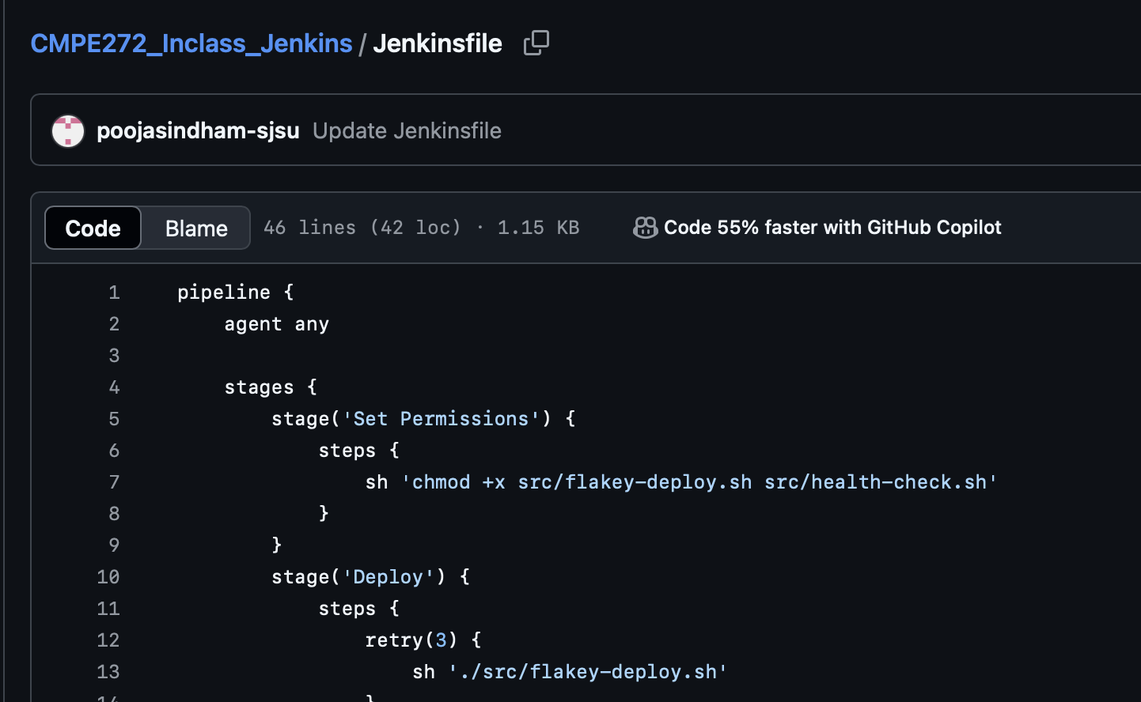

Multi pipeline ran Successfully.

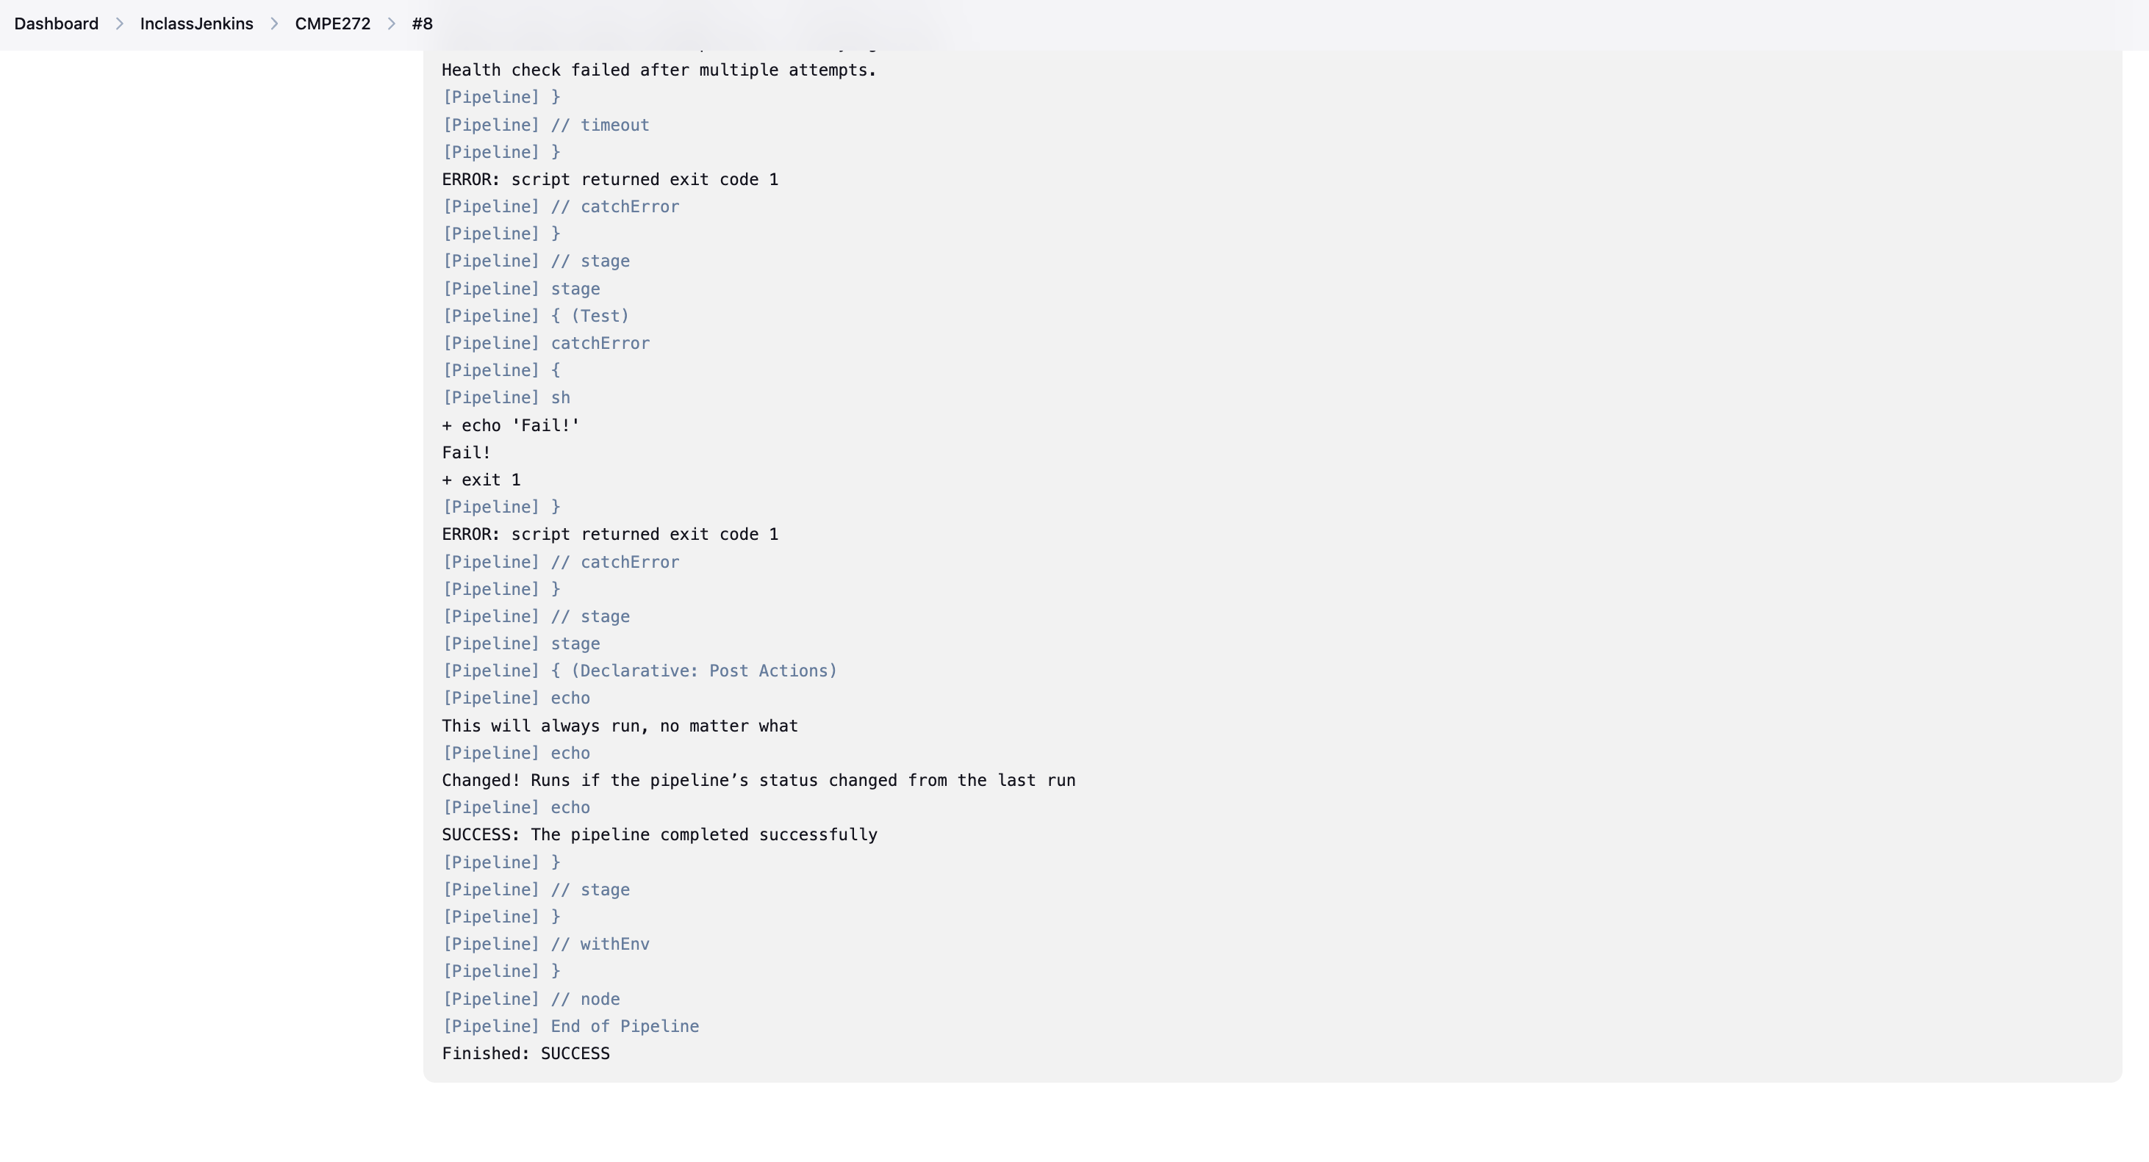

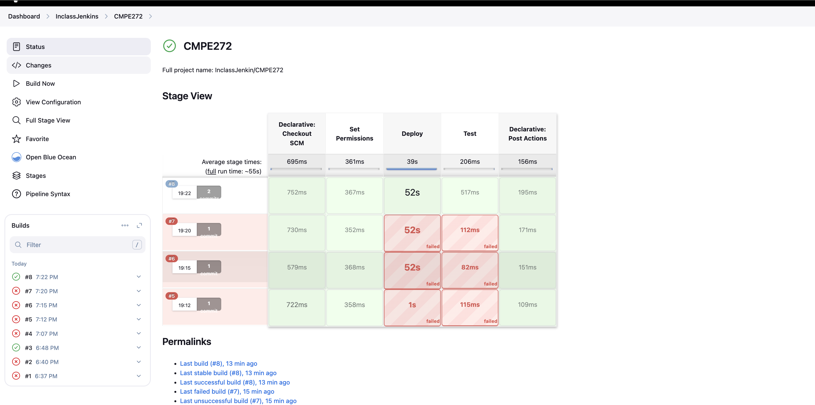

**Step 3: Defining Execution Environments**

Updating Jenkinsfile for Execution environment.

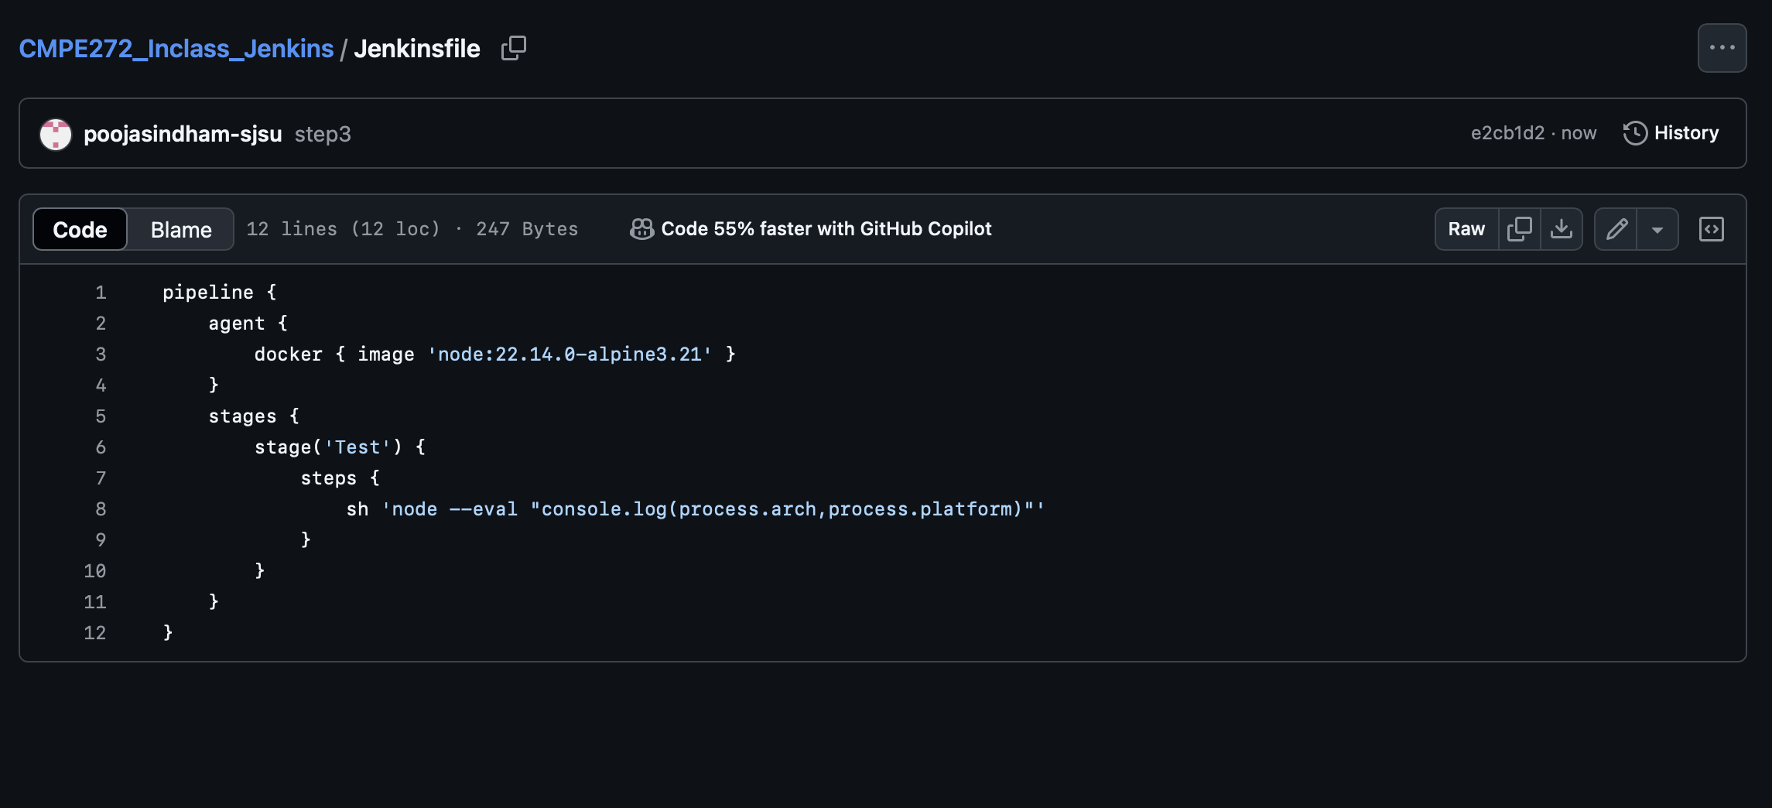

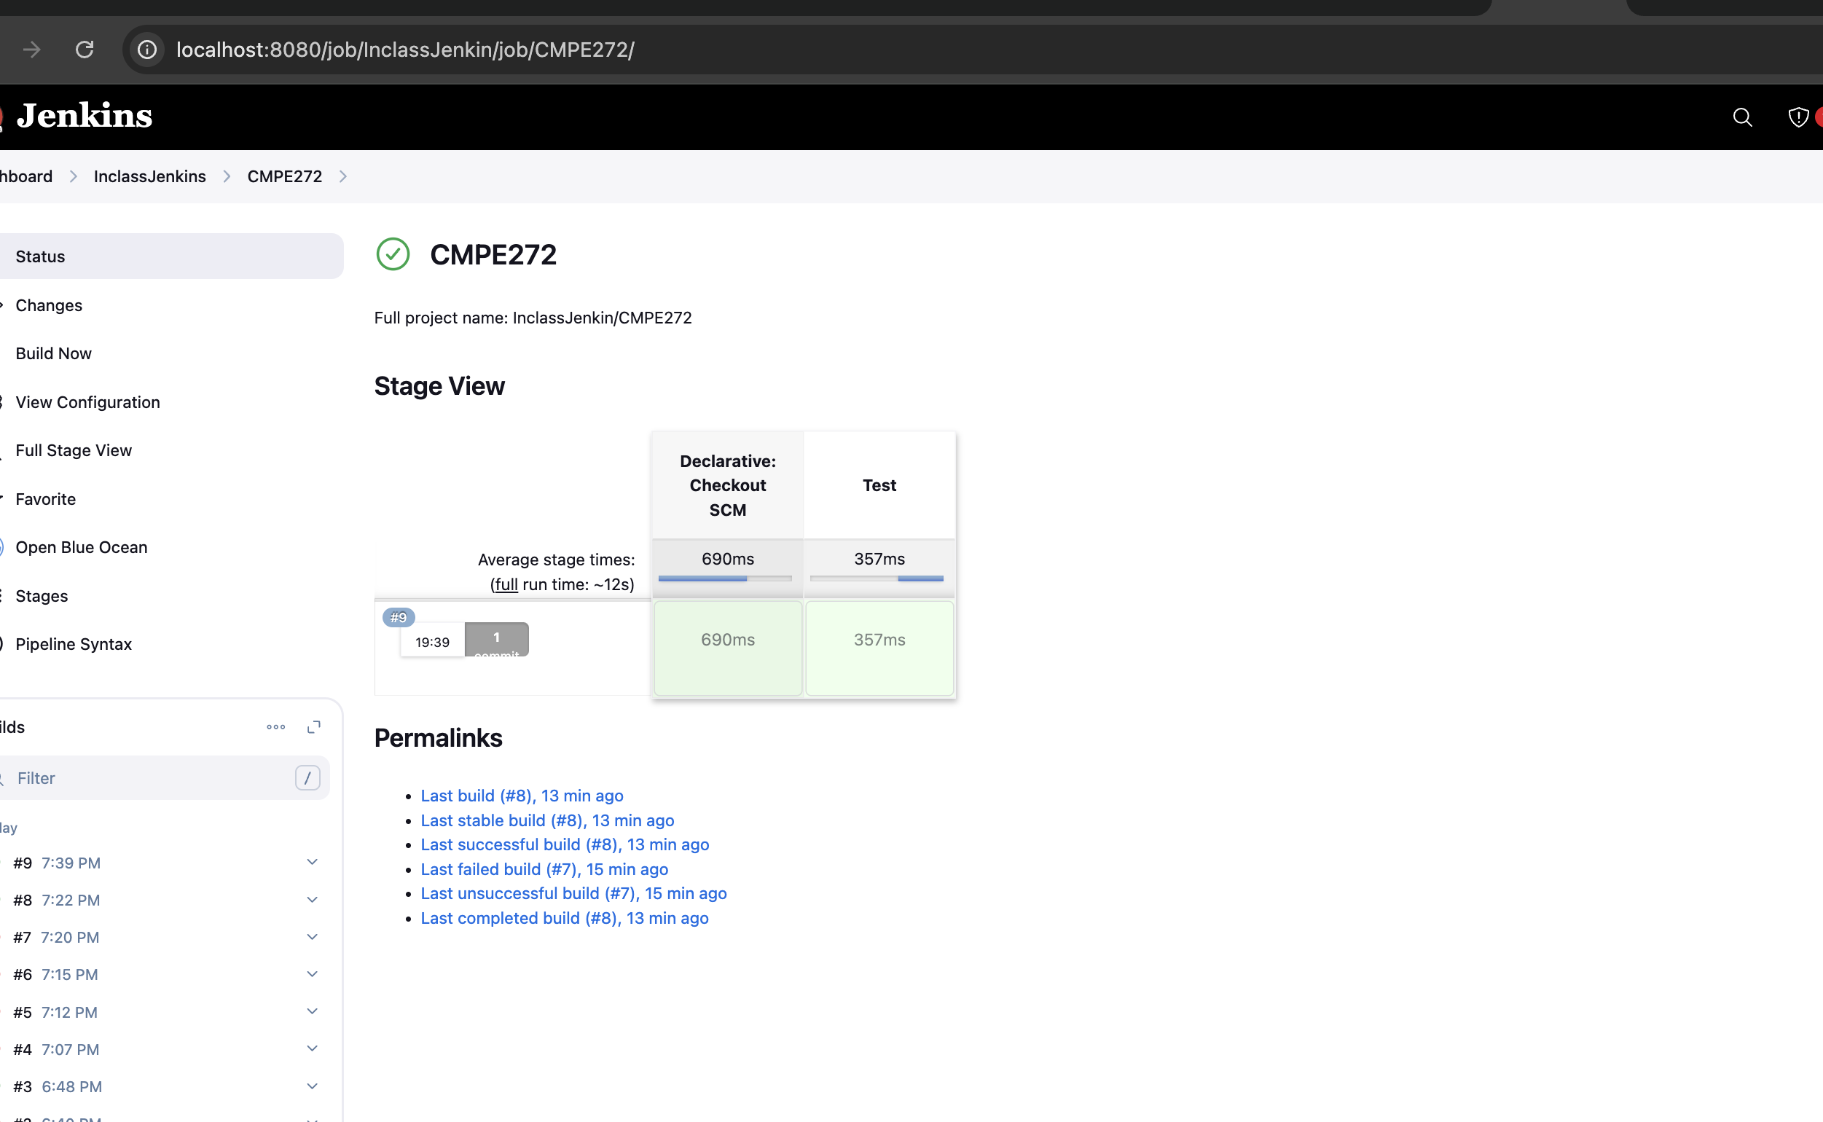

**Step 4: Using environment variables**

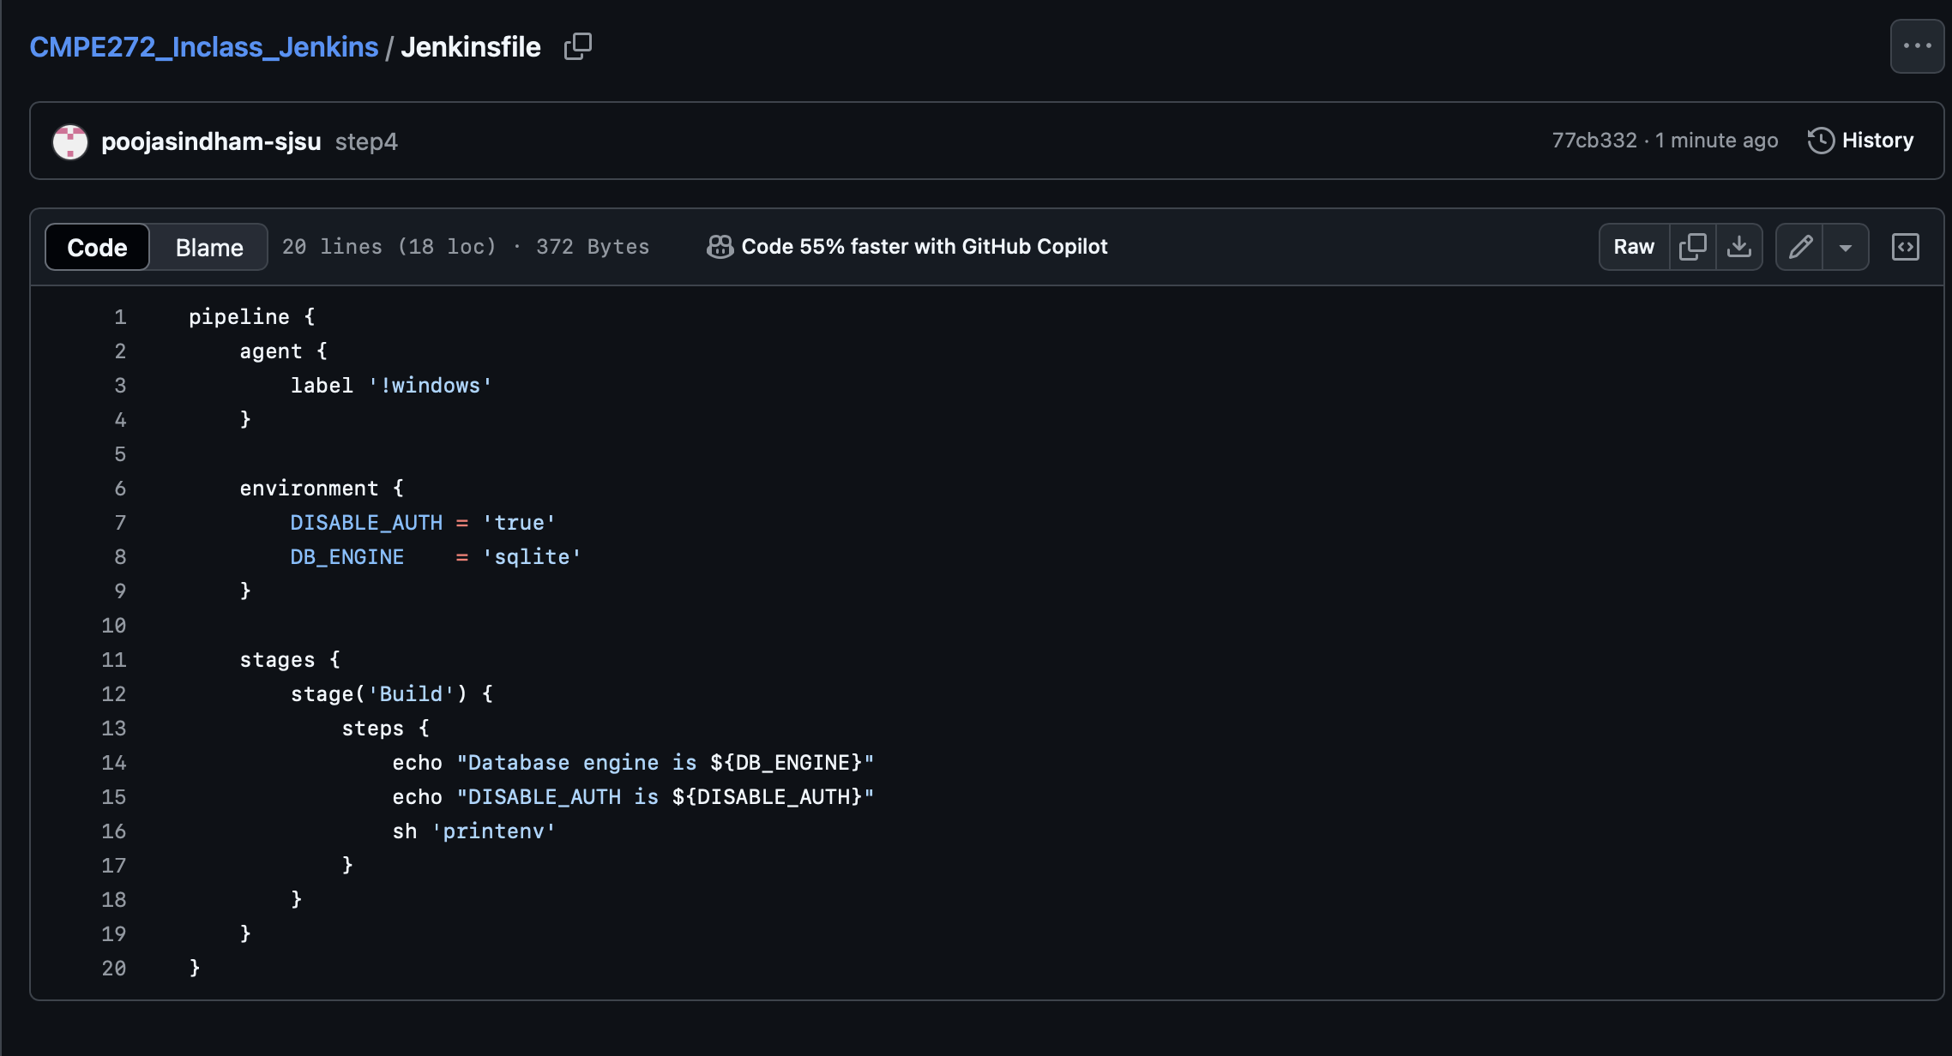

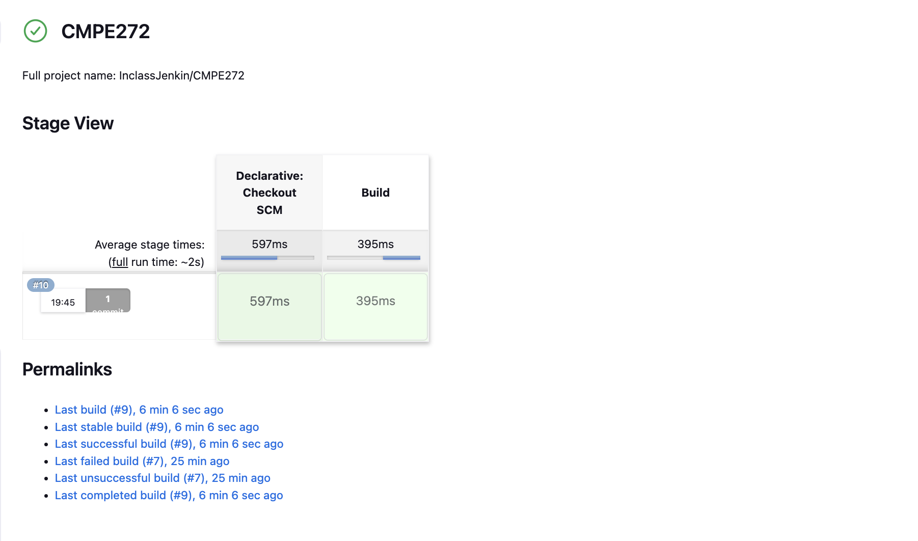

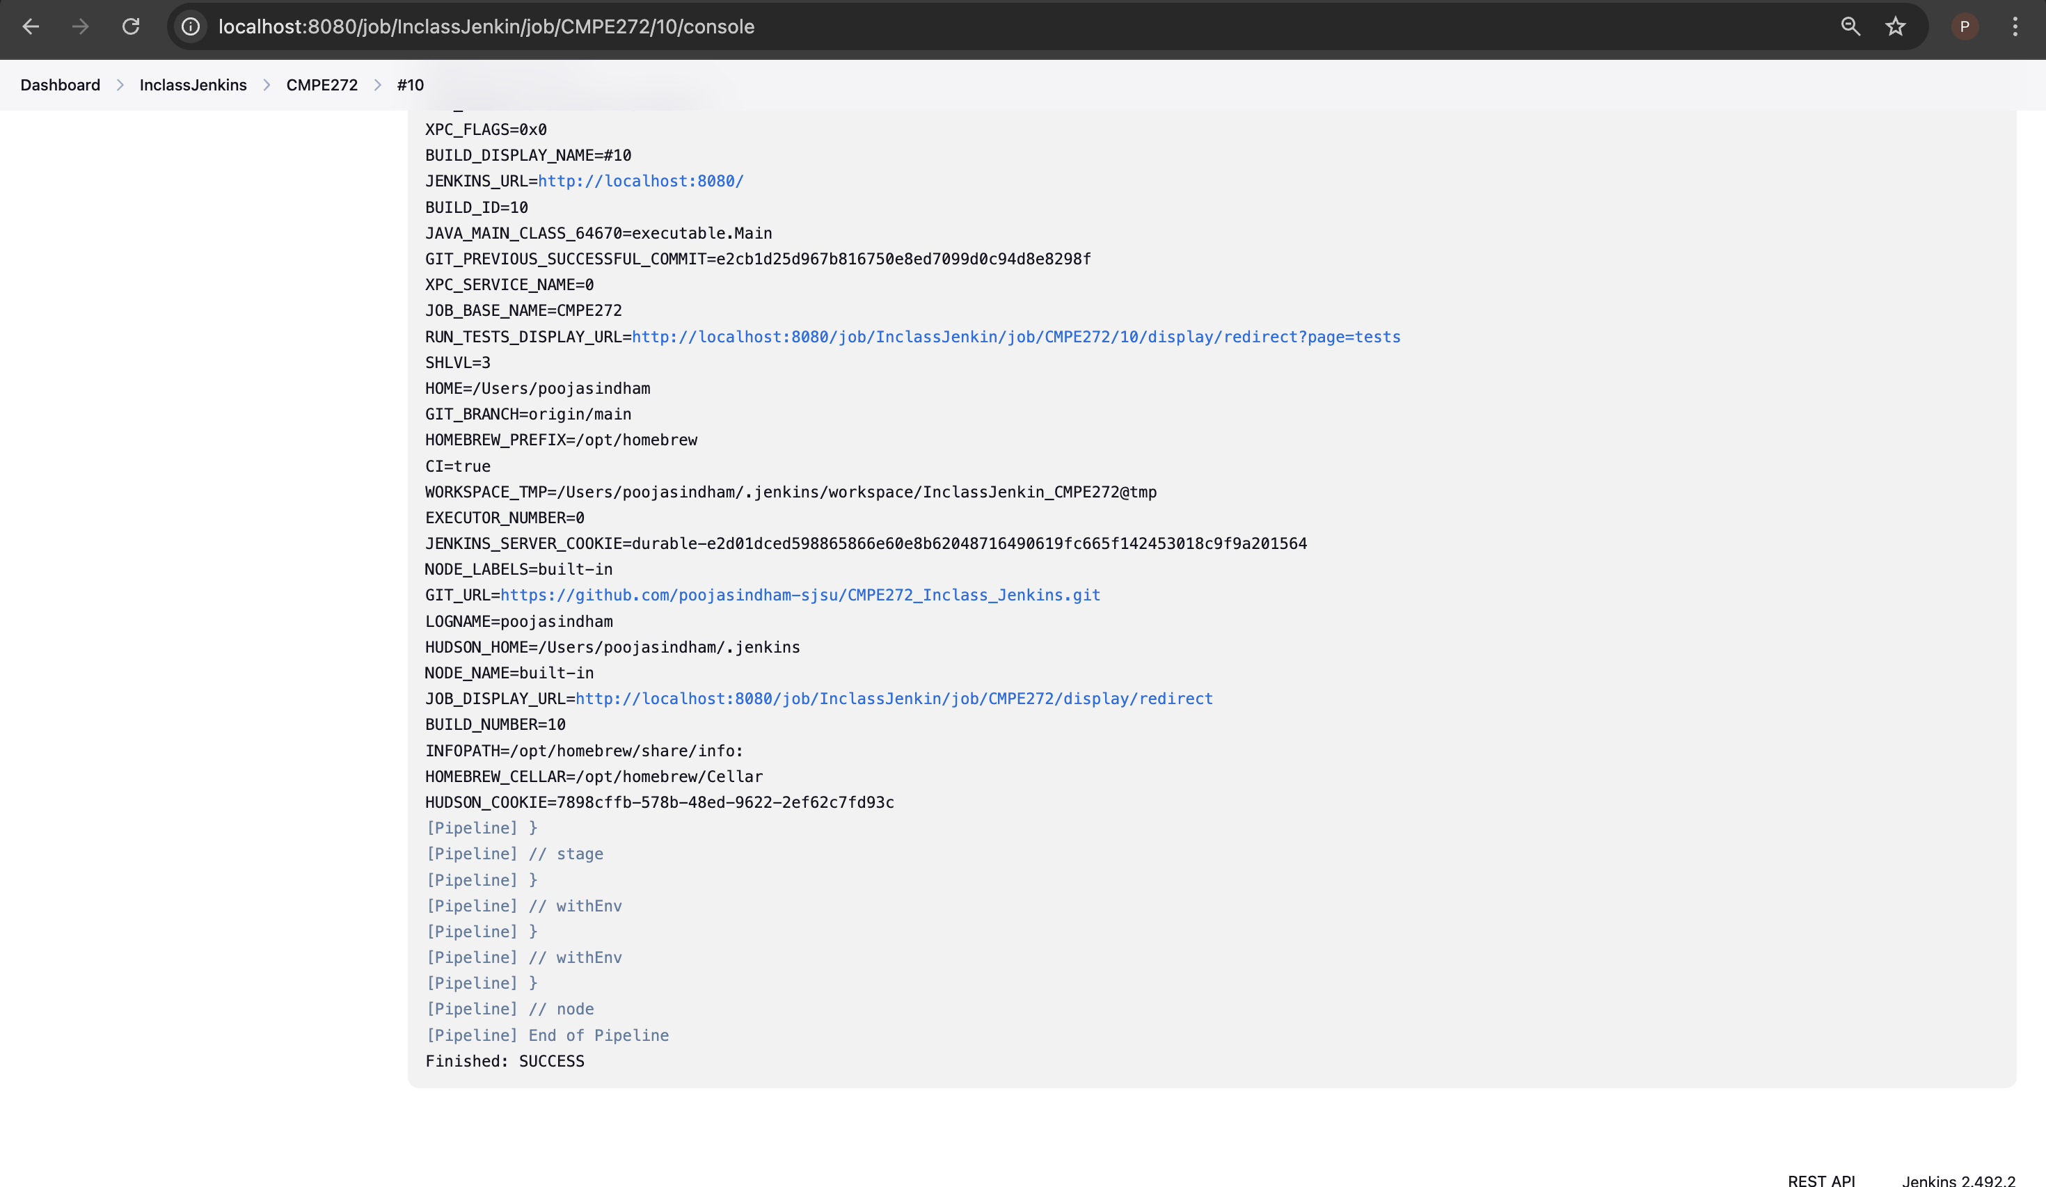

**Step 5: Recording tests and artifacts**

Update Jenkinsfile.

|  |
| --- |
| pipeline {  agent {  docker { image 'python:3.8' } // Use Python Docker image  }  stages {  stage('Setup') {  steps {  echo "Setting up virtual environment..."  sh '''  python -m venv venv  . venv/bin/activate # Use dot instead of source  pip install --upgrade pip  pip install -r requirements.txt  '''  }  }  stage('Run Tests') {  steps {  echo "Running tests..."  sh '''  . venv/bin/activate  venv/bin/pytest tests/test_sample.py --junitxml=test-results.xml # Use full path  '''  }  }  stage('Publish Test Results') {  steps {  echo "Publishing test results..."  catchError(buildResult: 'SUCCESS', stageResult: 'UNSTABLE') {  junit 'test-results.xml'  }  }  }  stage('Archive Artifacts') {  steps {  echo "Archiving logs and test reports..."  archiveArtifacts artifacts: 'logs/test.log, reports/report.html', fingerprint: true  }  }  }  post {  always {  echo "Pipeline execution complete!"  }  success {  echo "SUCCESS: Tests executed, results published, and artifacts stored!"  }  unstable {  echo "Some tests failed, but results and artifacts are available."  }  }  } |

Created file to test artifacts and archive.

* A sample Python test file using *pytest*.
* A log file to archive.
* A dummy report file to store as an artifact.
* A *.gitignore* to avoid unnecessary files in the repo.

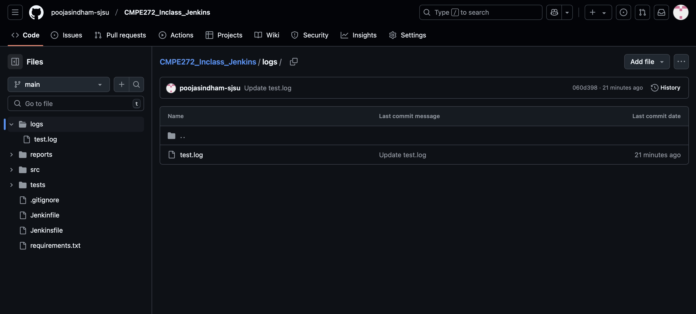  
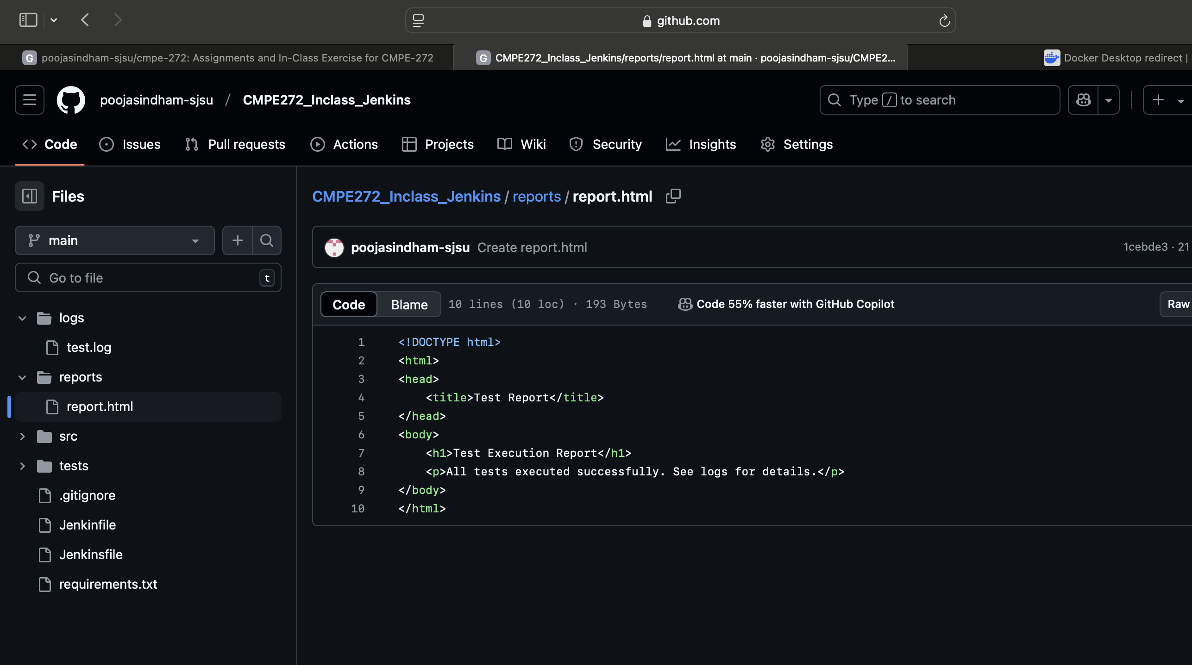

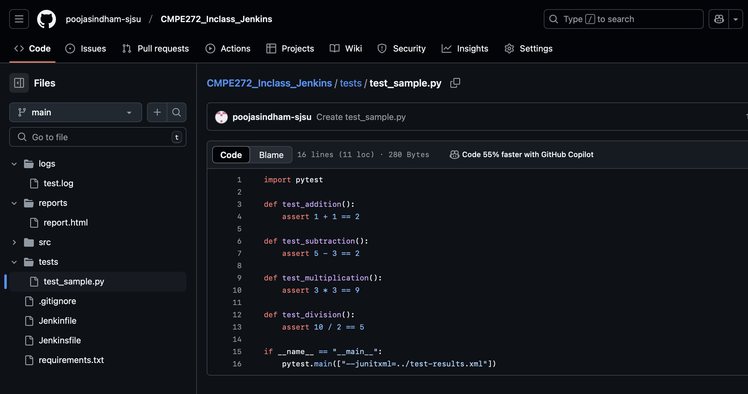

Pipeline ran Successfully.

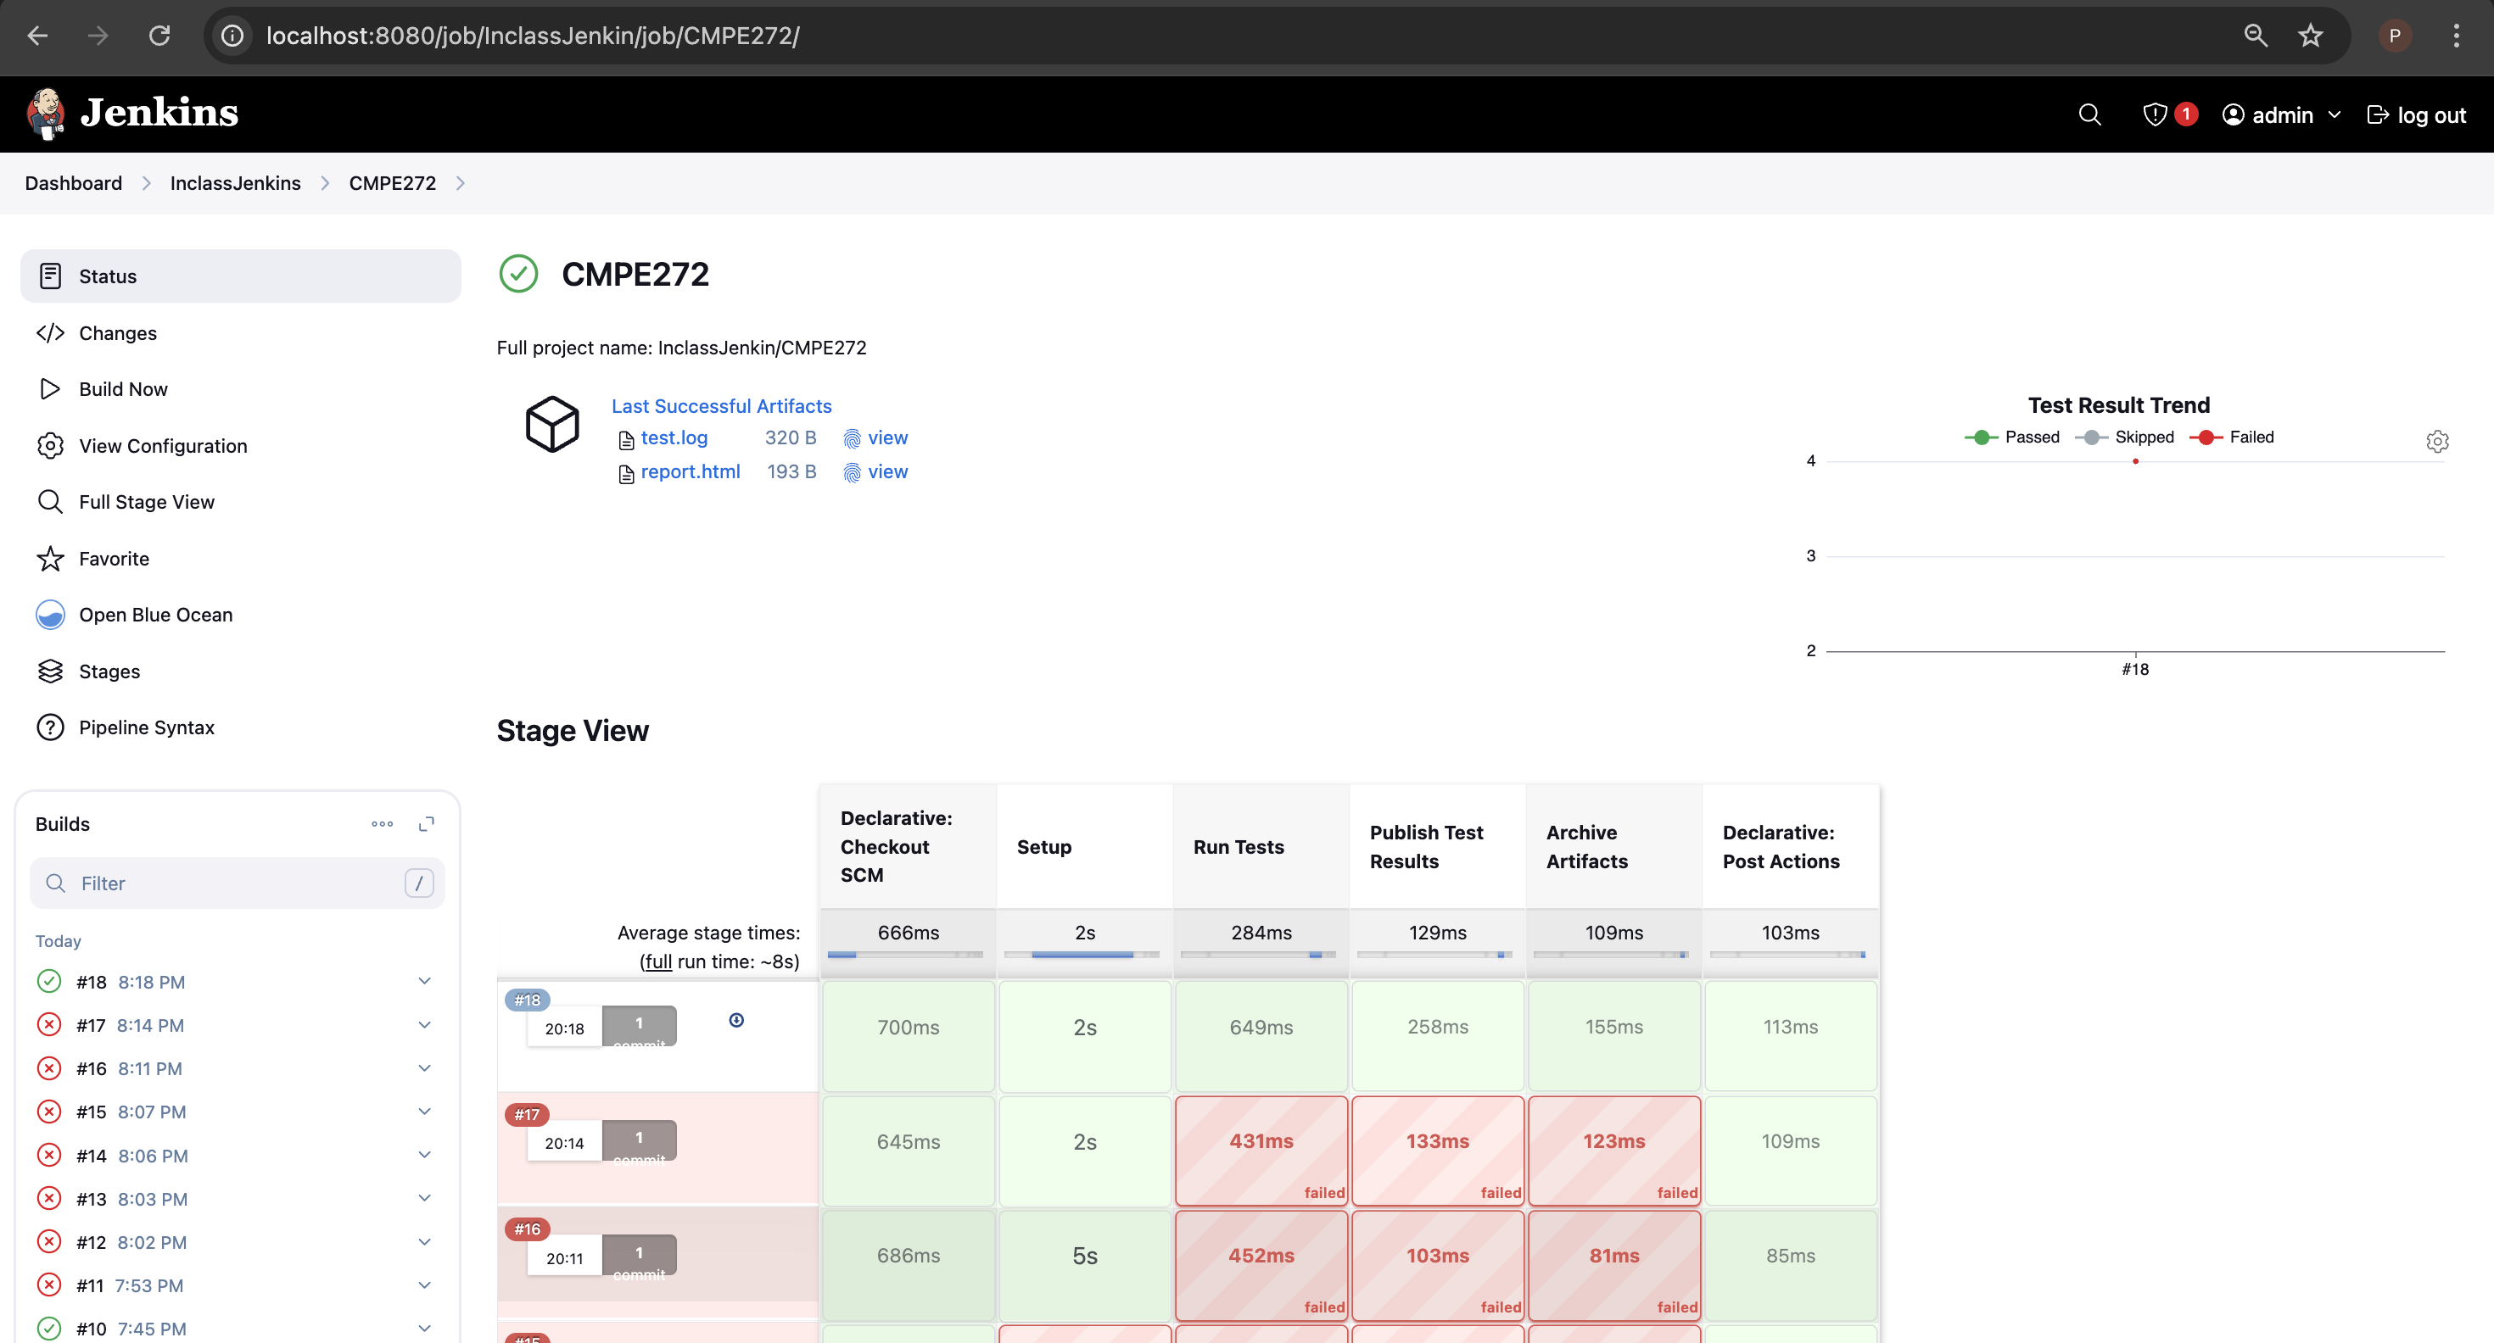

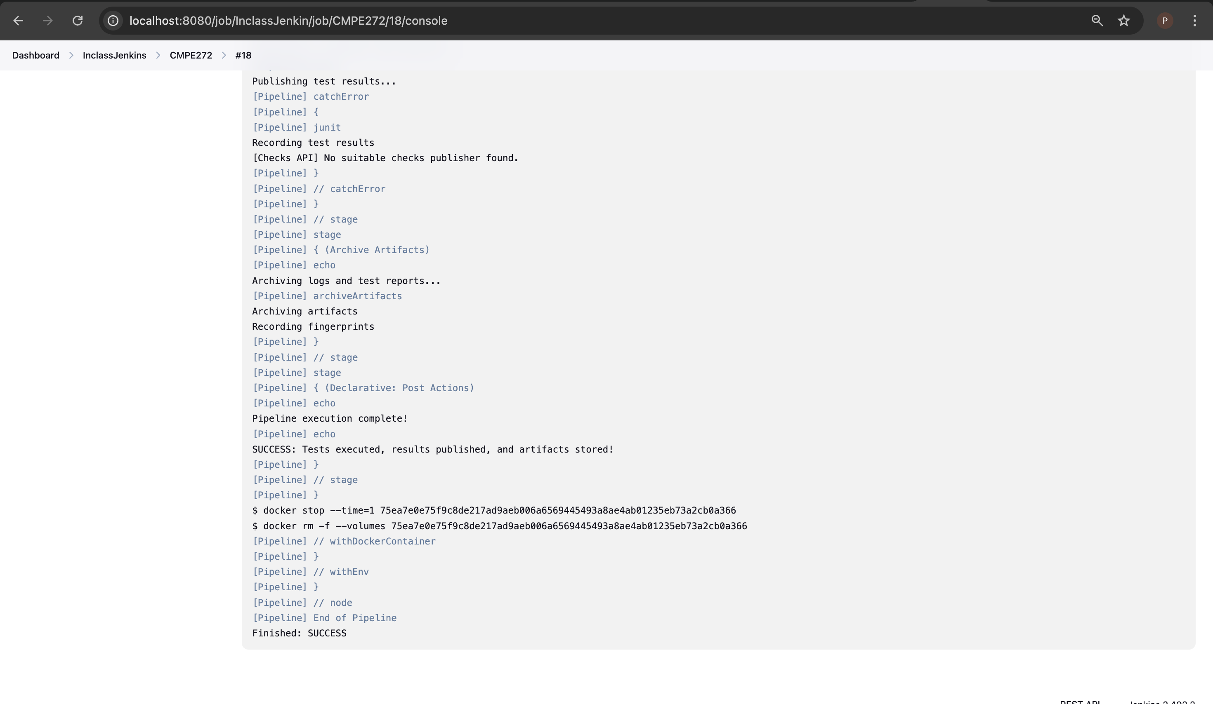

**Step 6: Cleaning Up and Notifications**

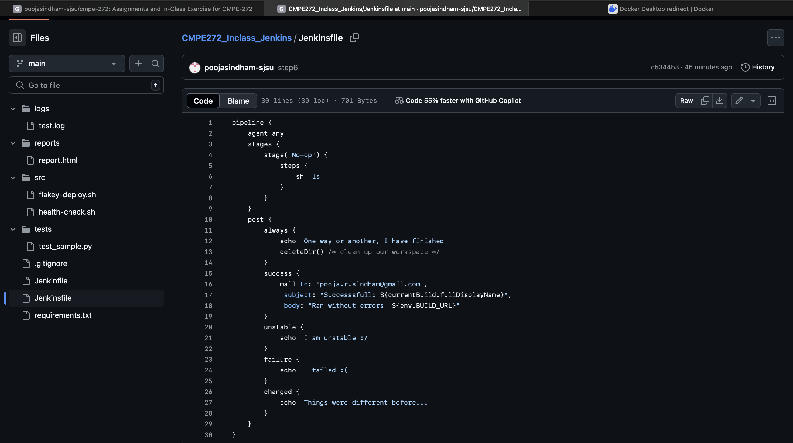

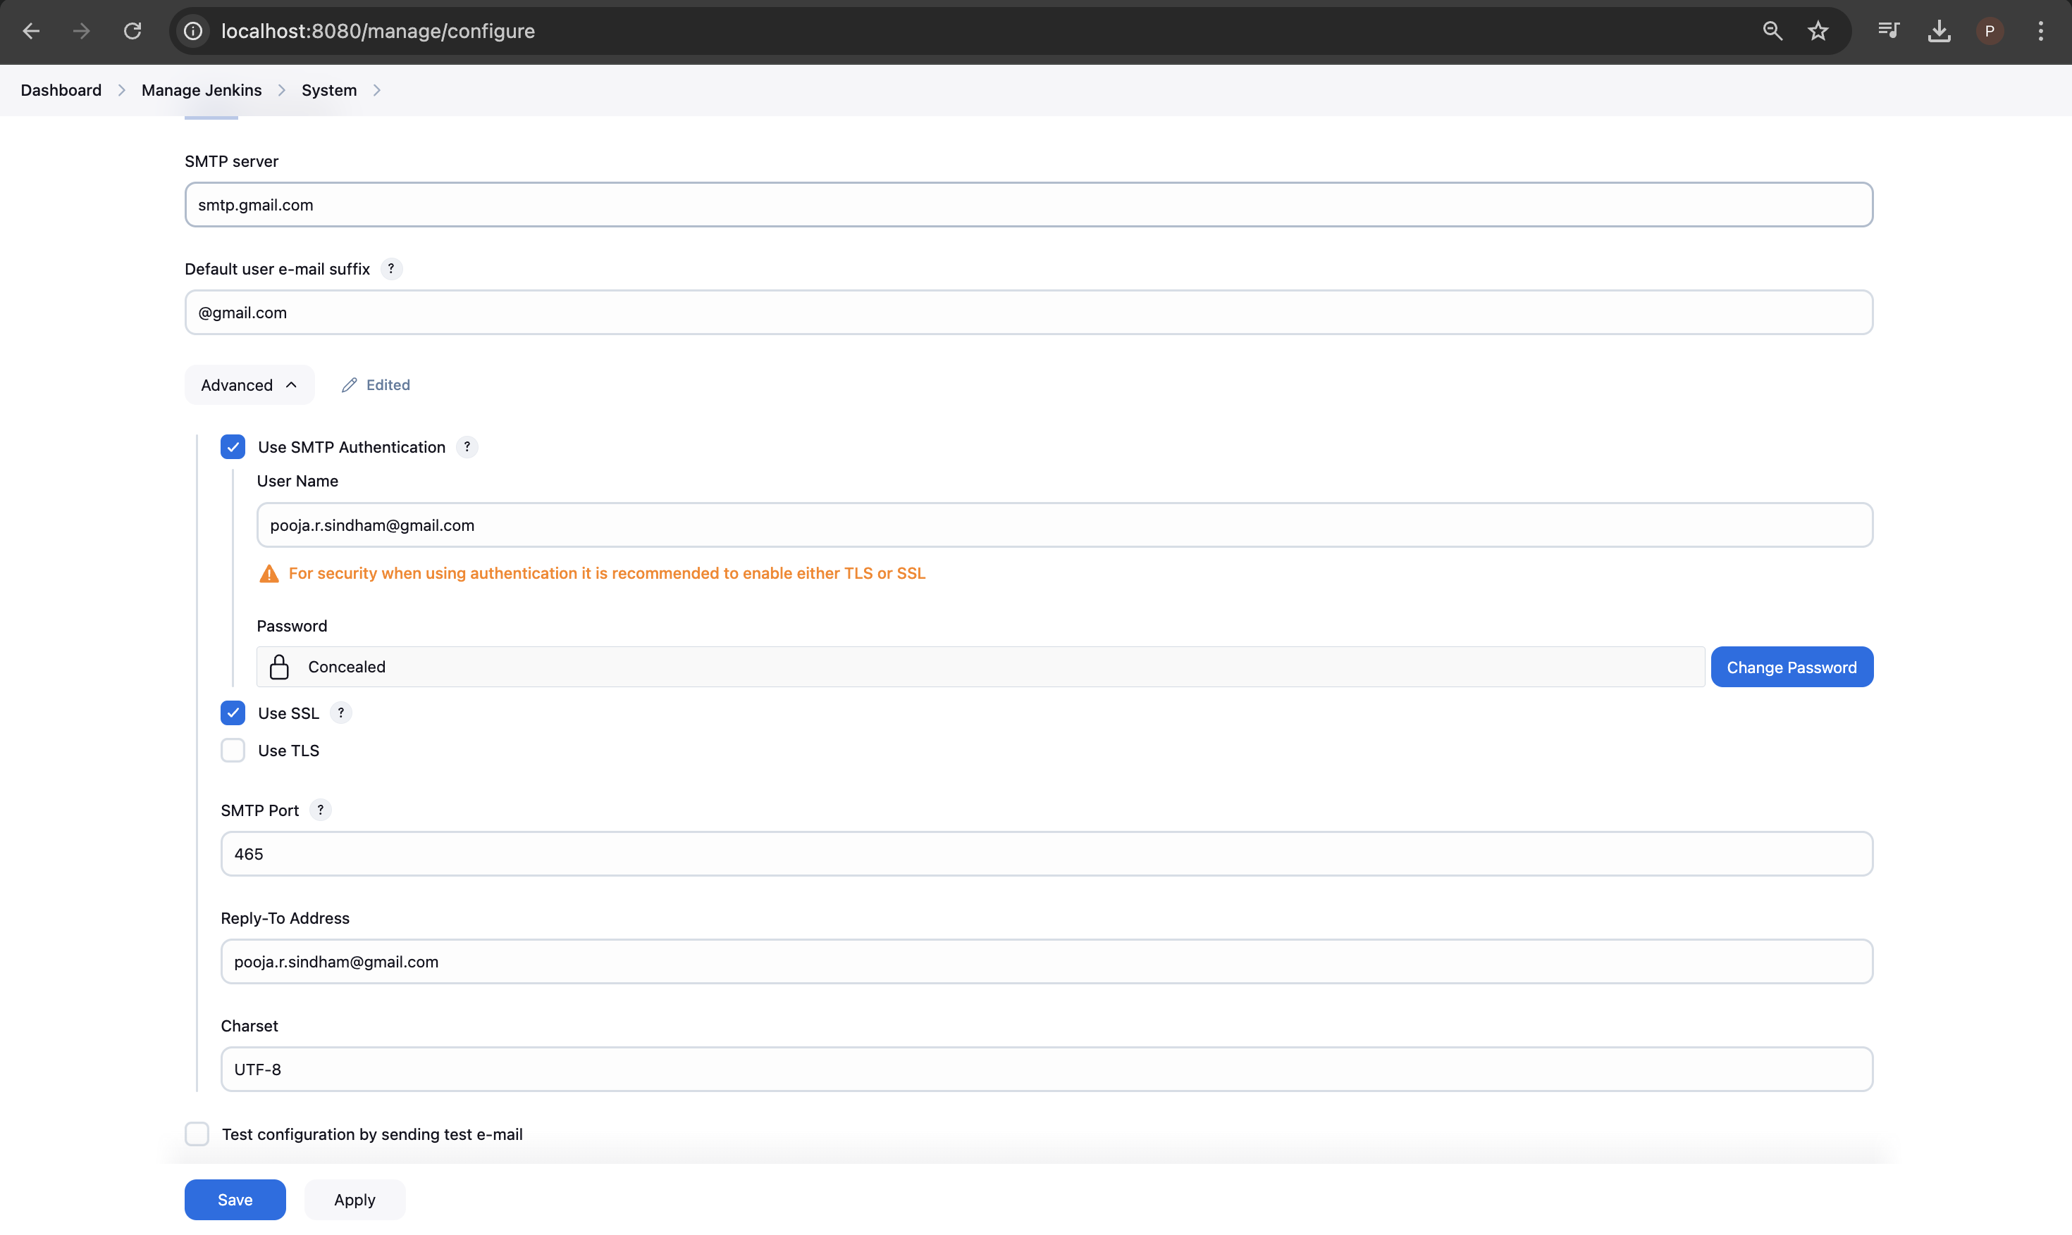

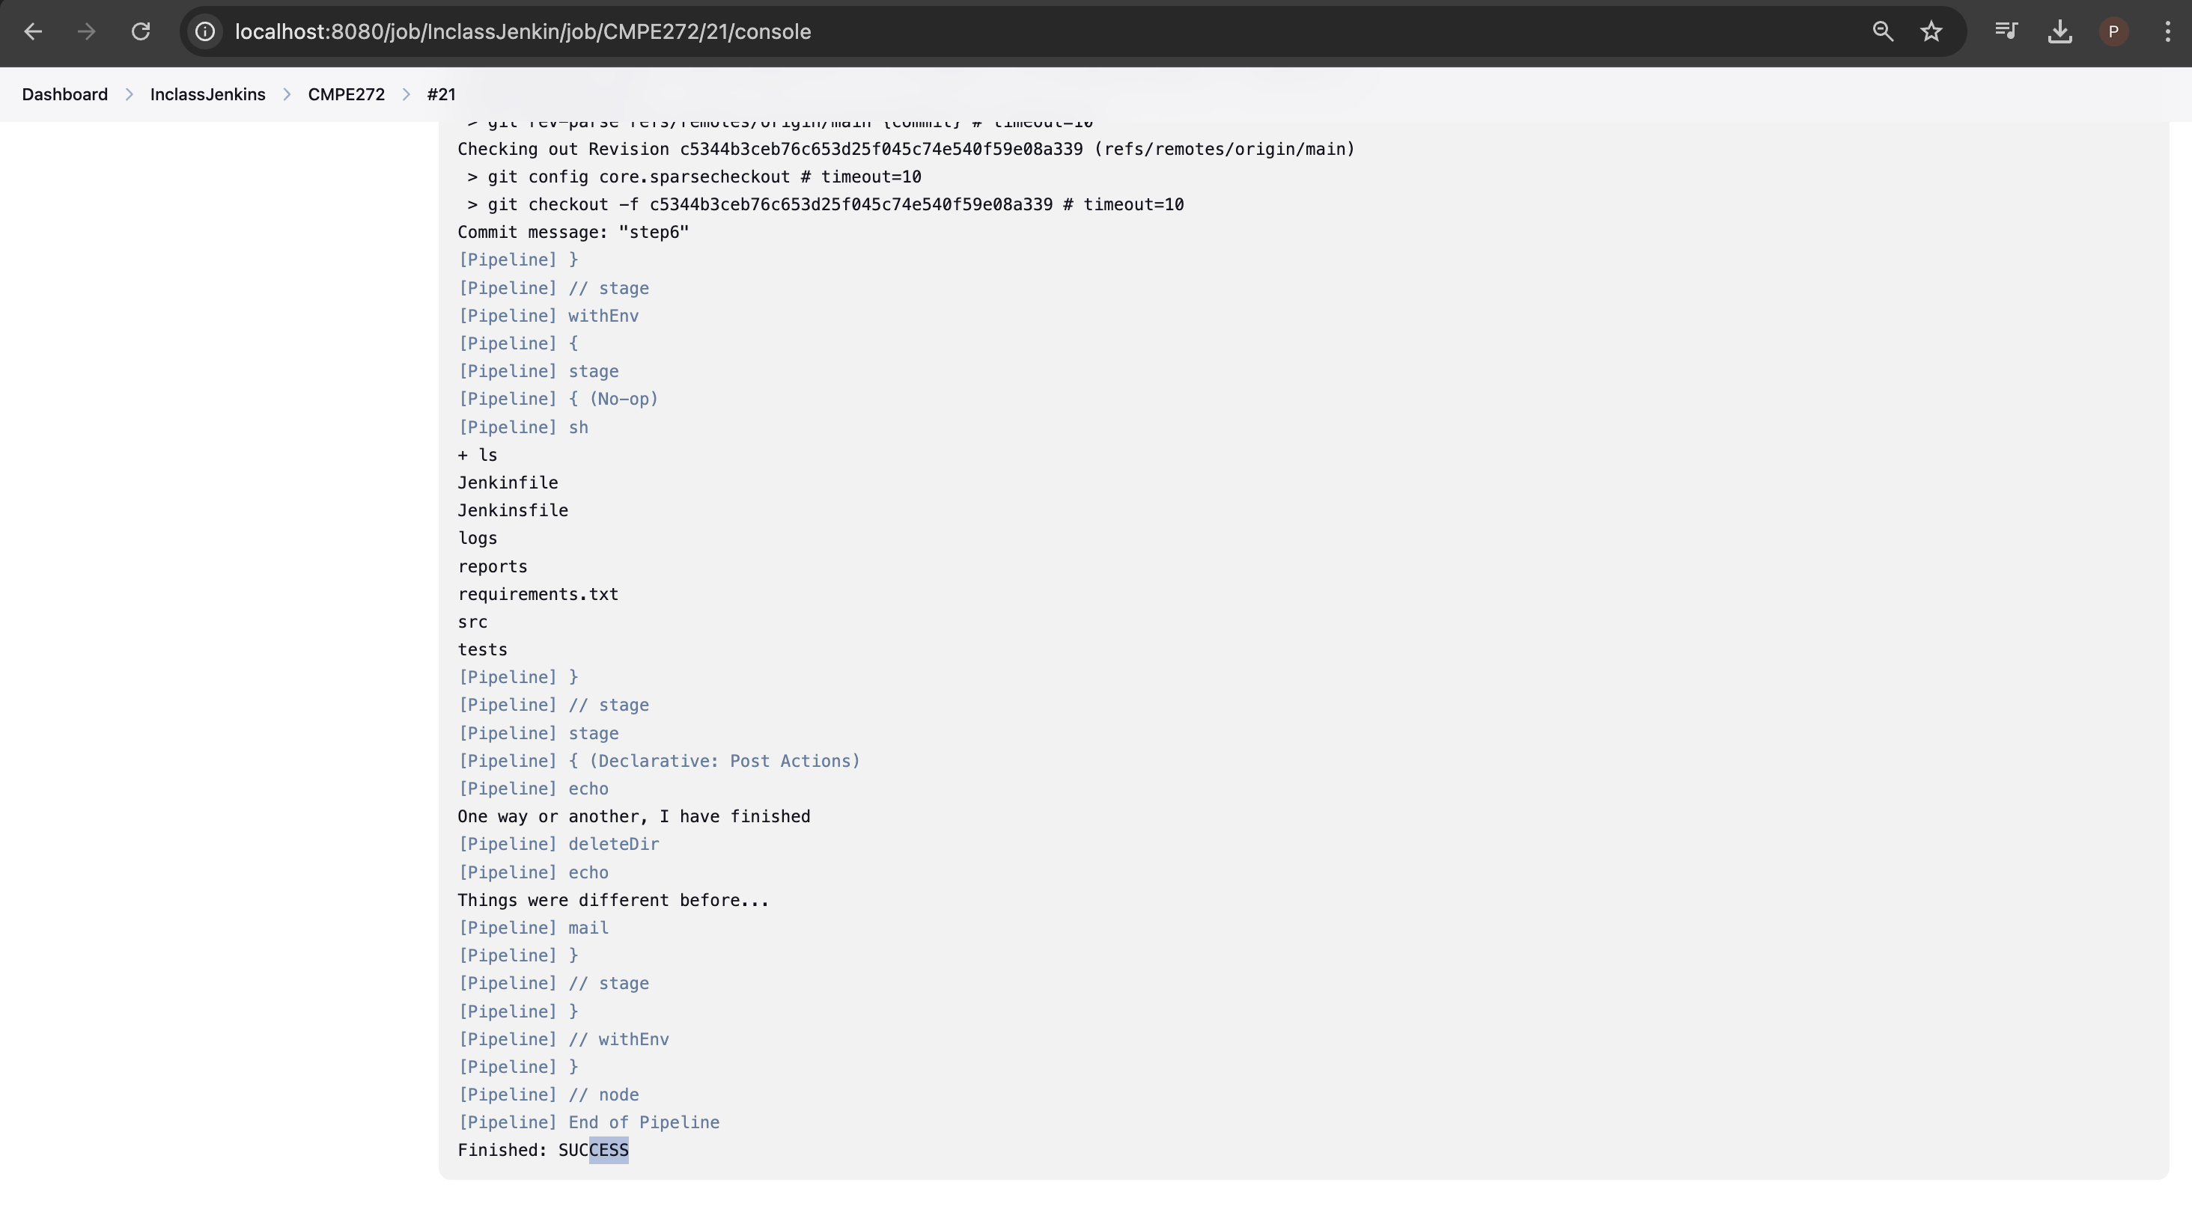

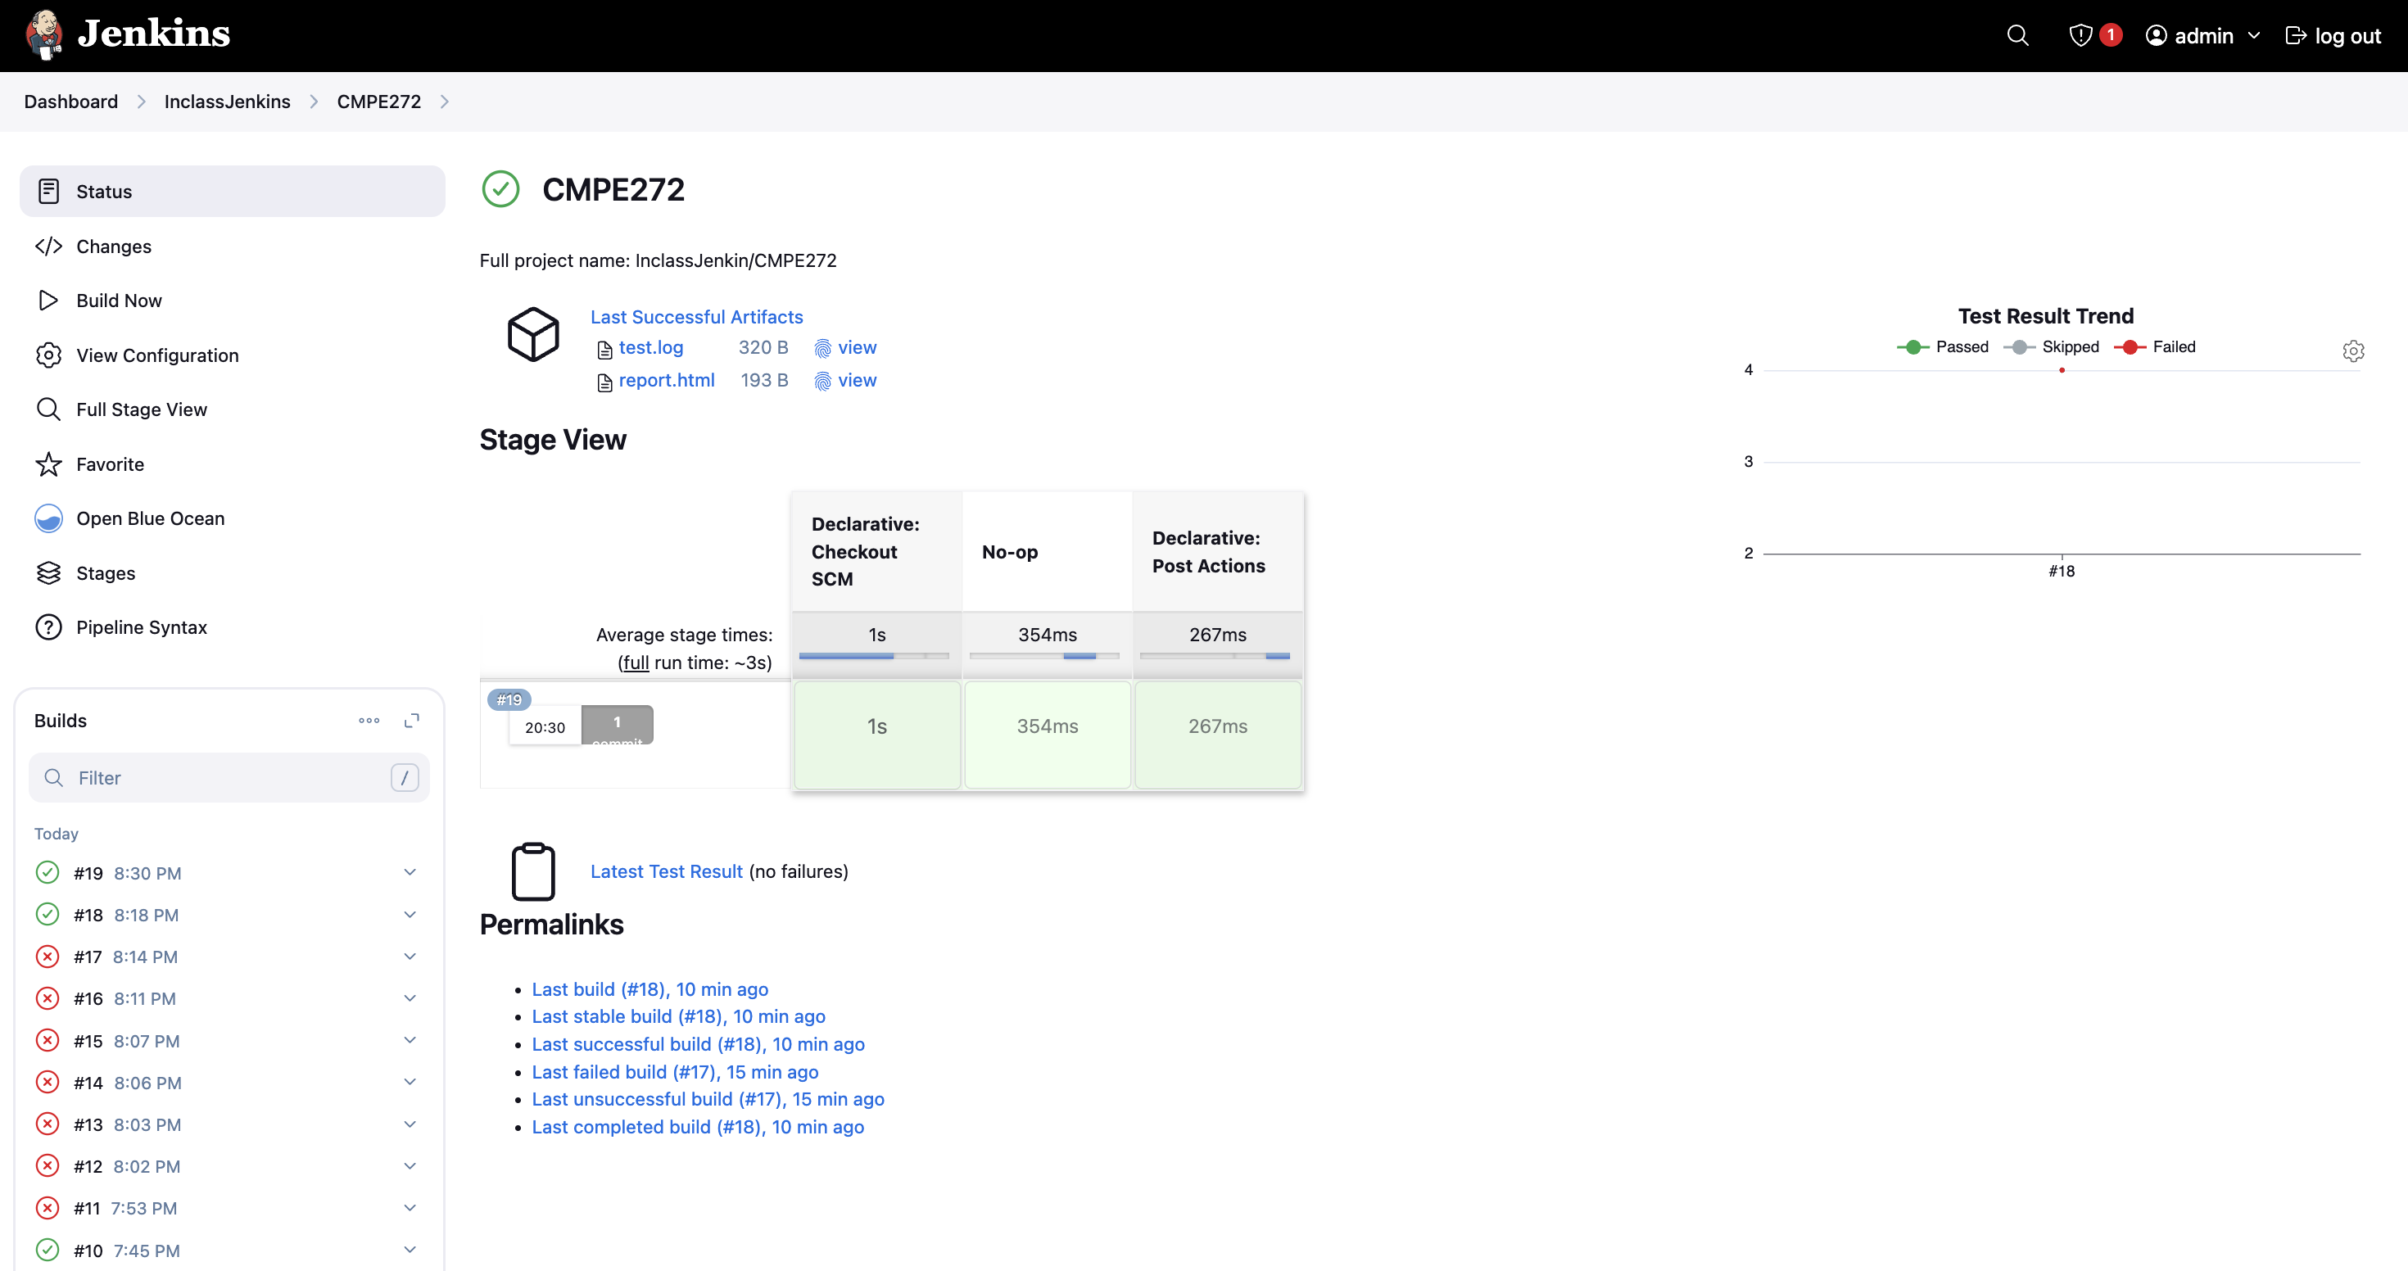

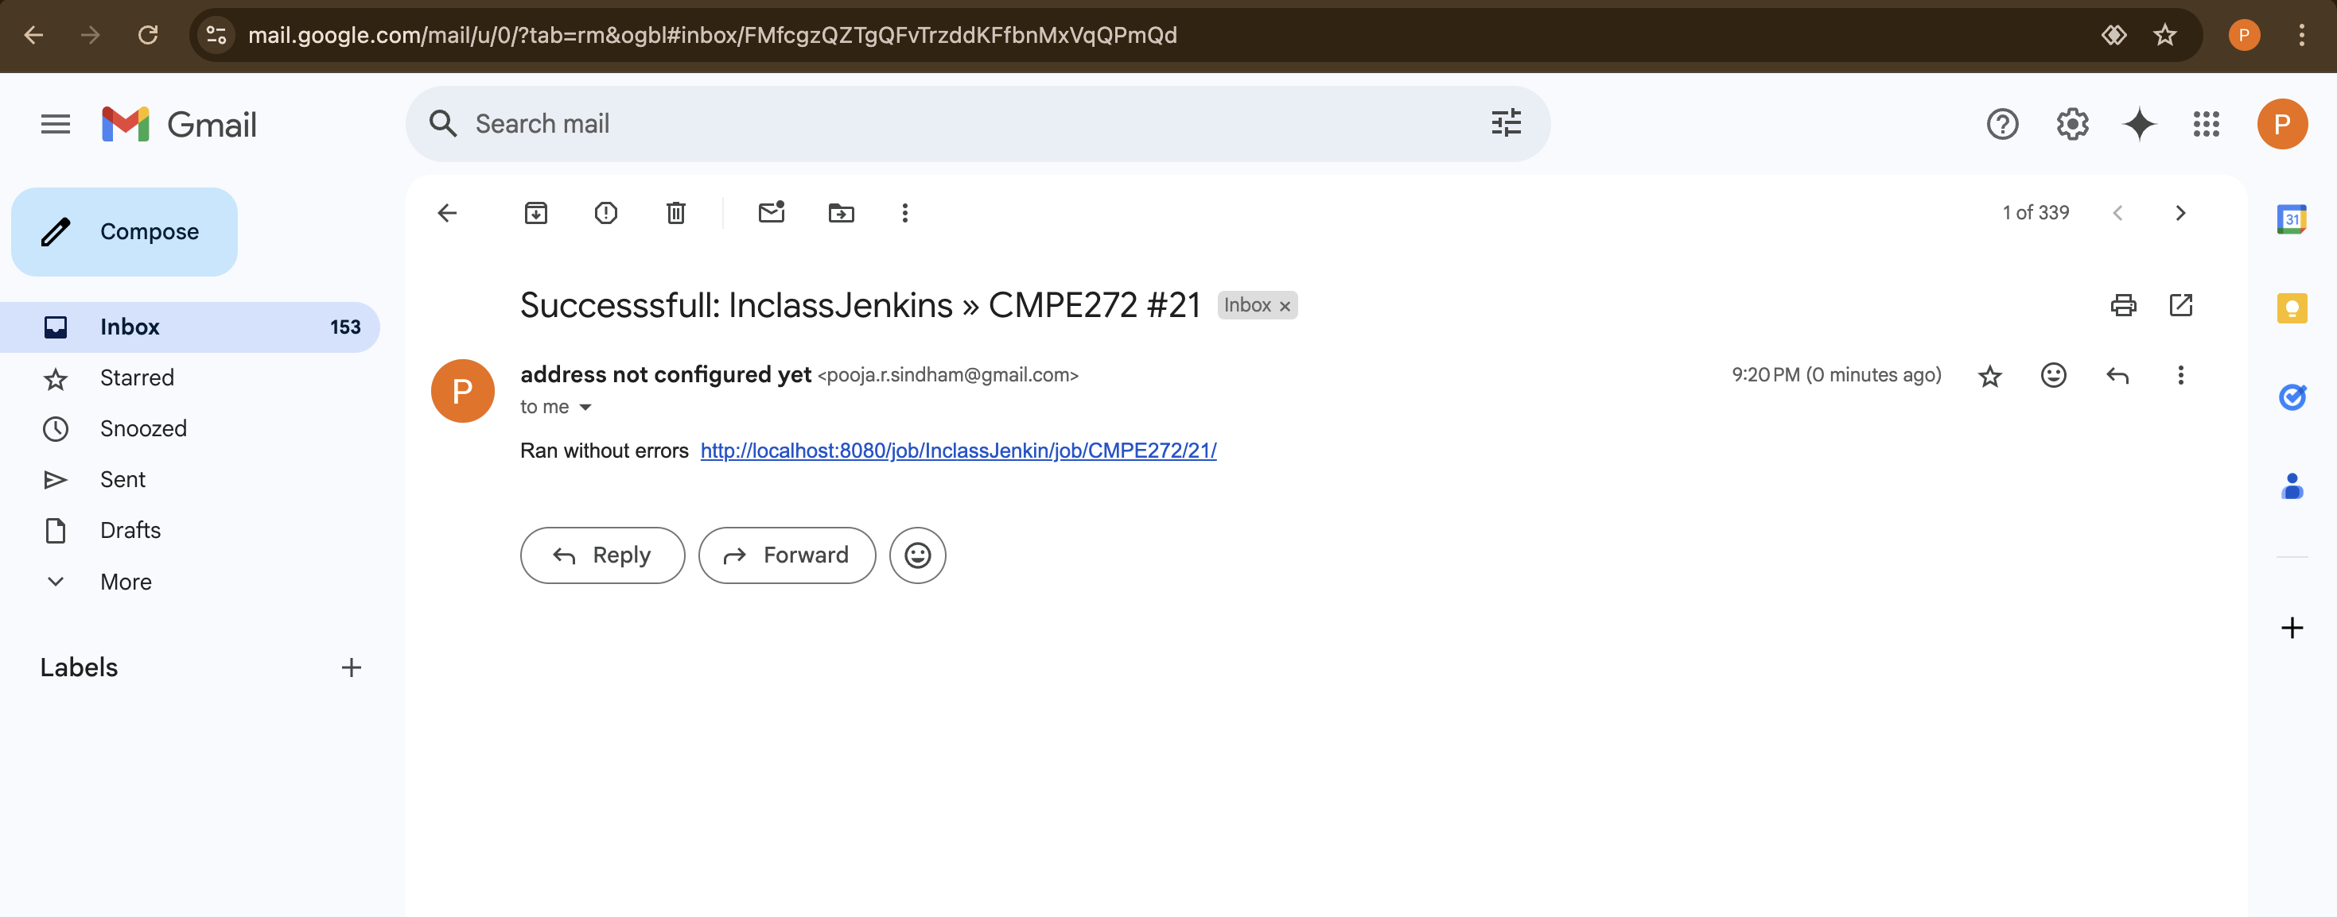

**Step 7: Deployment.**  
  
Created one sample index.html and deploying it on AWS EC2 instances through Jenkins.

*index.html*

|  |
| --- |
| <!DOCTYPE html>  <html lang="en">  <head>  <meta charset="UTF-8">  <meta name="viewport" content="width=device-width, initial-scale=1.0">  <title>Jenkins Deployment on AWS</title>  <style>  body {  font-family: Arial, sans-serif;  margin: 0;  padding: 0;  text-align: center;  background: linear-gradient(135deg, #ff7e5f, #feb47b);  color: white;  }  .container {  width: 80%;  margin: 100px auto;  padding: 20px;  background: rgba(255, 255, 255, 0.1);  border-radius: 10px;  box-shadow: 0px 4px 8px rgba(0, 0, 0, 0.1);  }  h1 {  font-size: 2.5em;  }  p {  font-size: 1.2em;  }  .btn {  display: inline-block;  padding: 10px 20px;  margin-top: 20px;  background: #fff;  color: #ff7e5f;  text-decoration: none;  font-weight: bold;  border-radius: 5px;  transition: 0.3s;  }  .btn:hover {  background: #ff7e5f;  color: #fff;  }  </style>  </head>  <body>  <div class="container">  <h1>🚀 Jenkins Deployment on AWS EC2</h1>  <p>This page has been successfully deployed using Jenkins.</p>  <p>Enjoy automated CI/CD pipelines with GitHub, Jenkins, and AWS!</p>  <a href="https://github.com/poojasindham-sjsu/CMPE272_Inclass_Jenkins" class="btn" target="_blank">View Repository</a>  </div>  </body>  </html> |

*JenkinsFile*

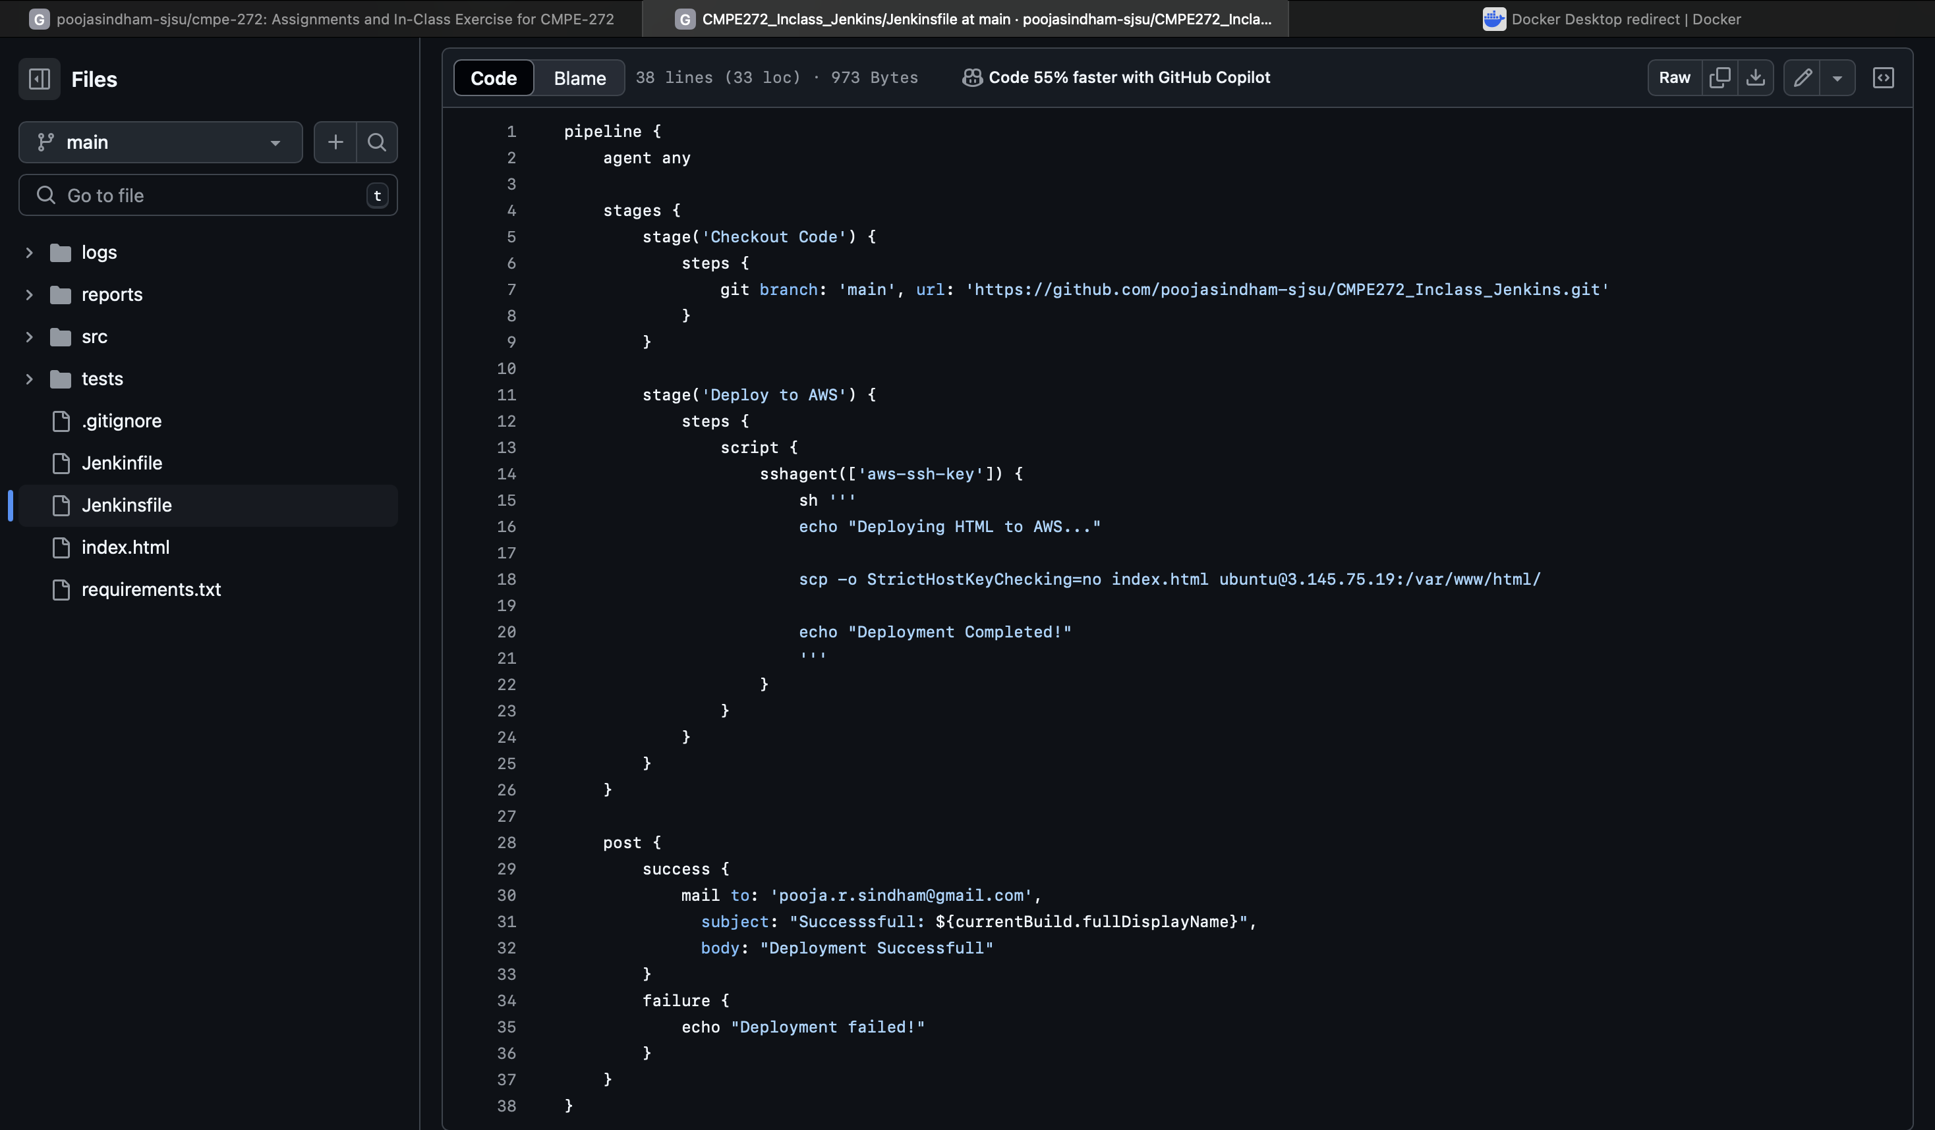

Adding credentials in Jenkins

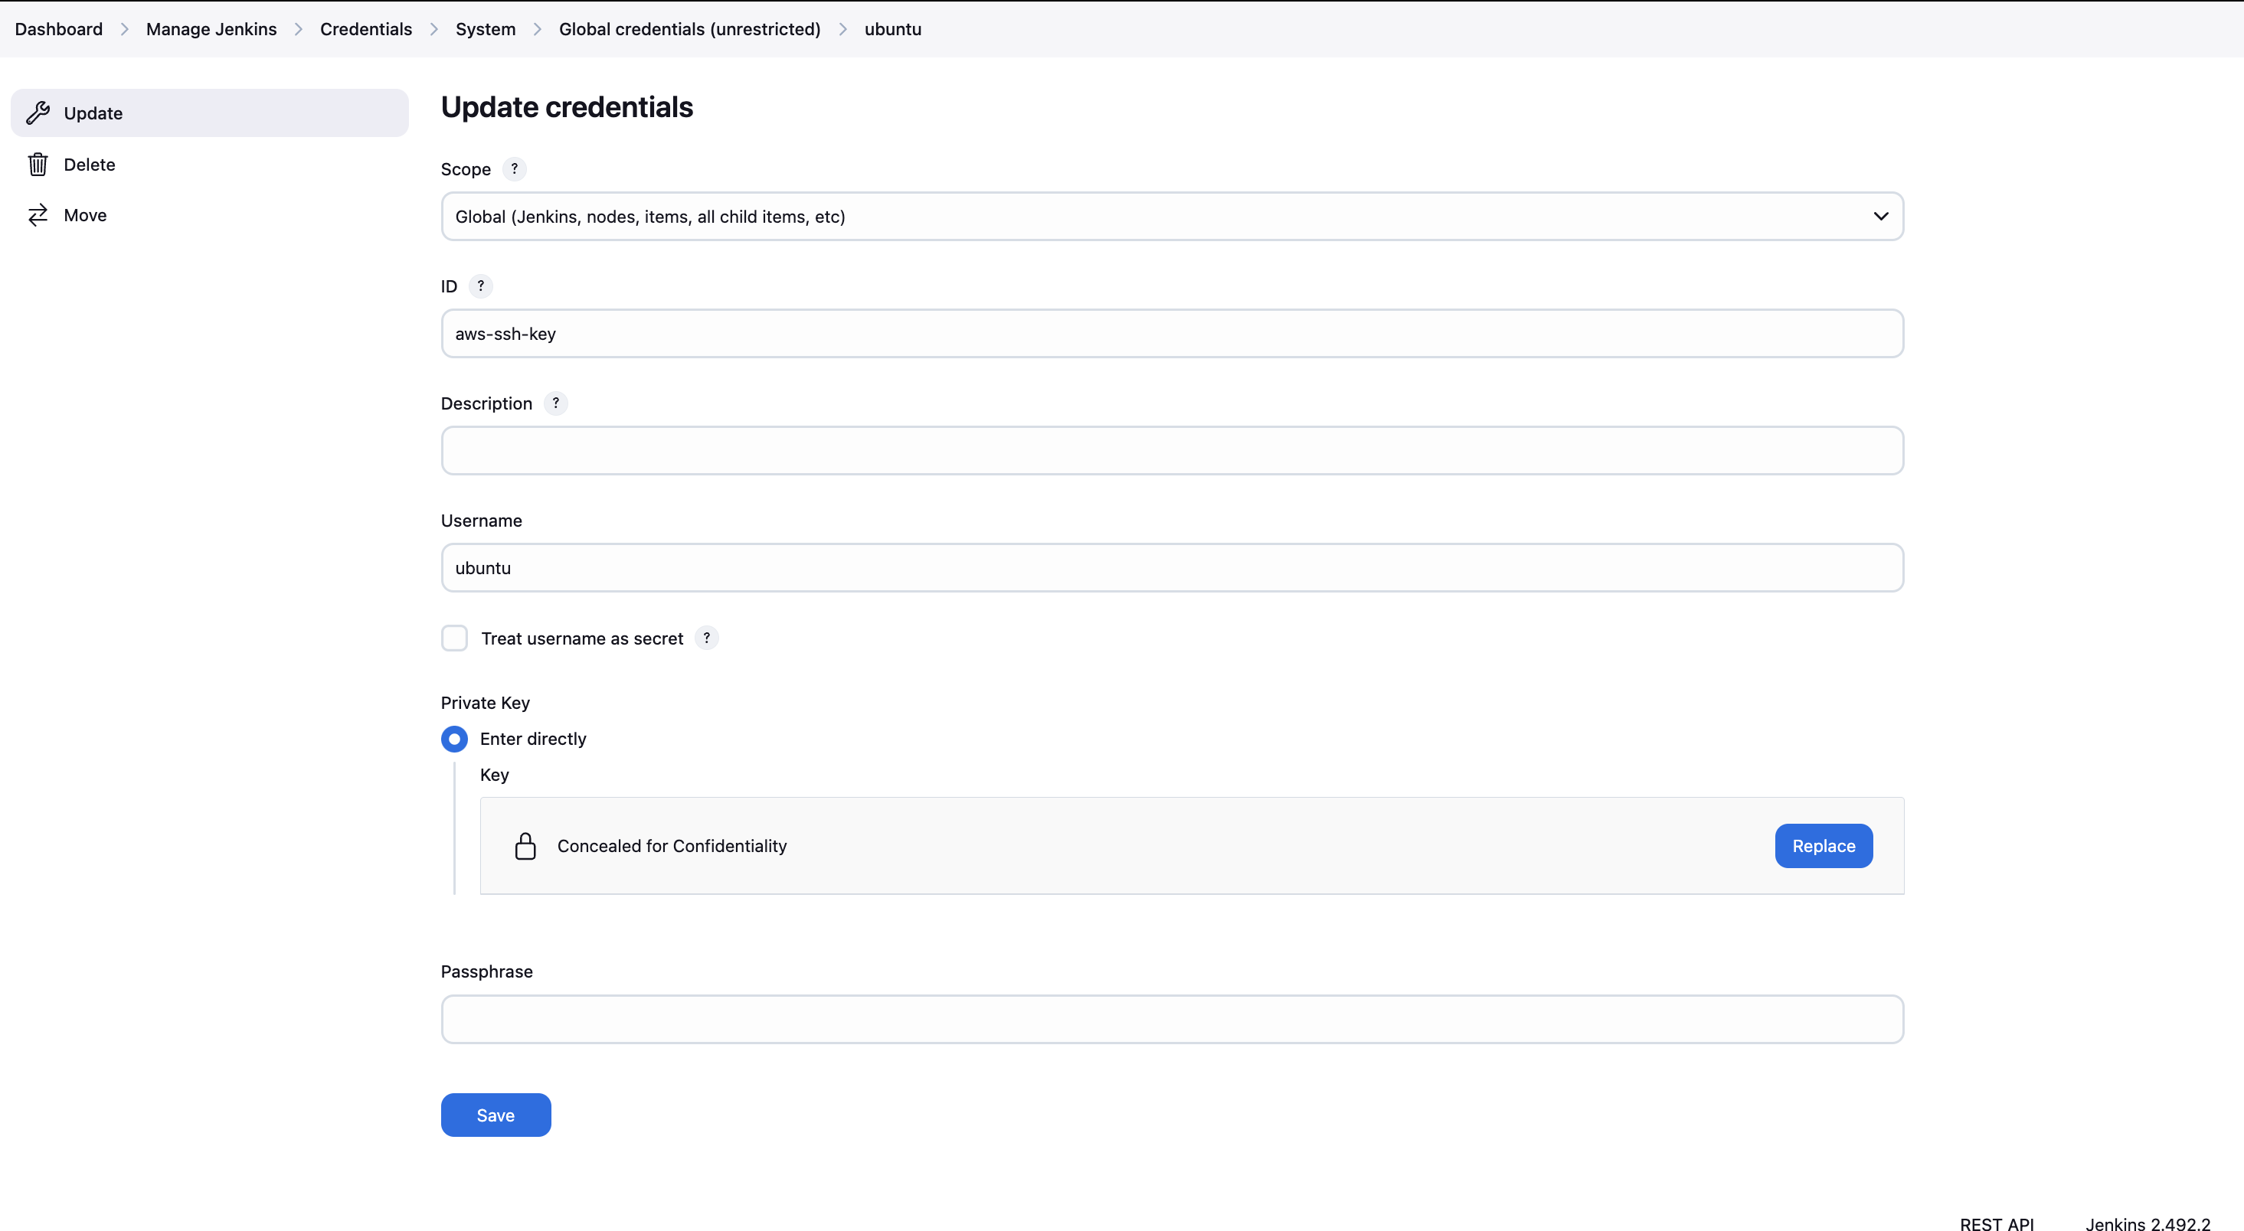

Email received for successful deployment

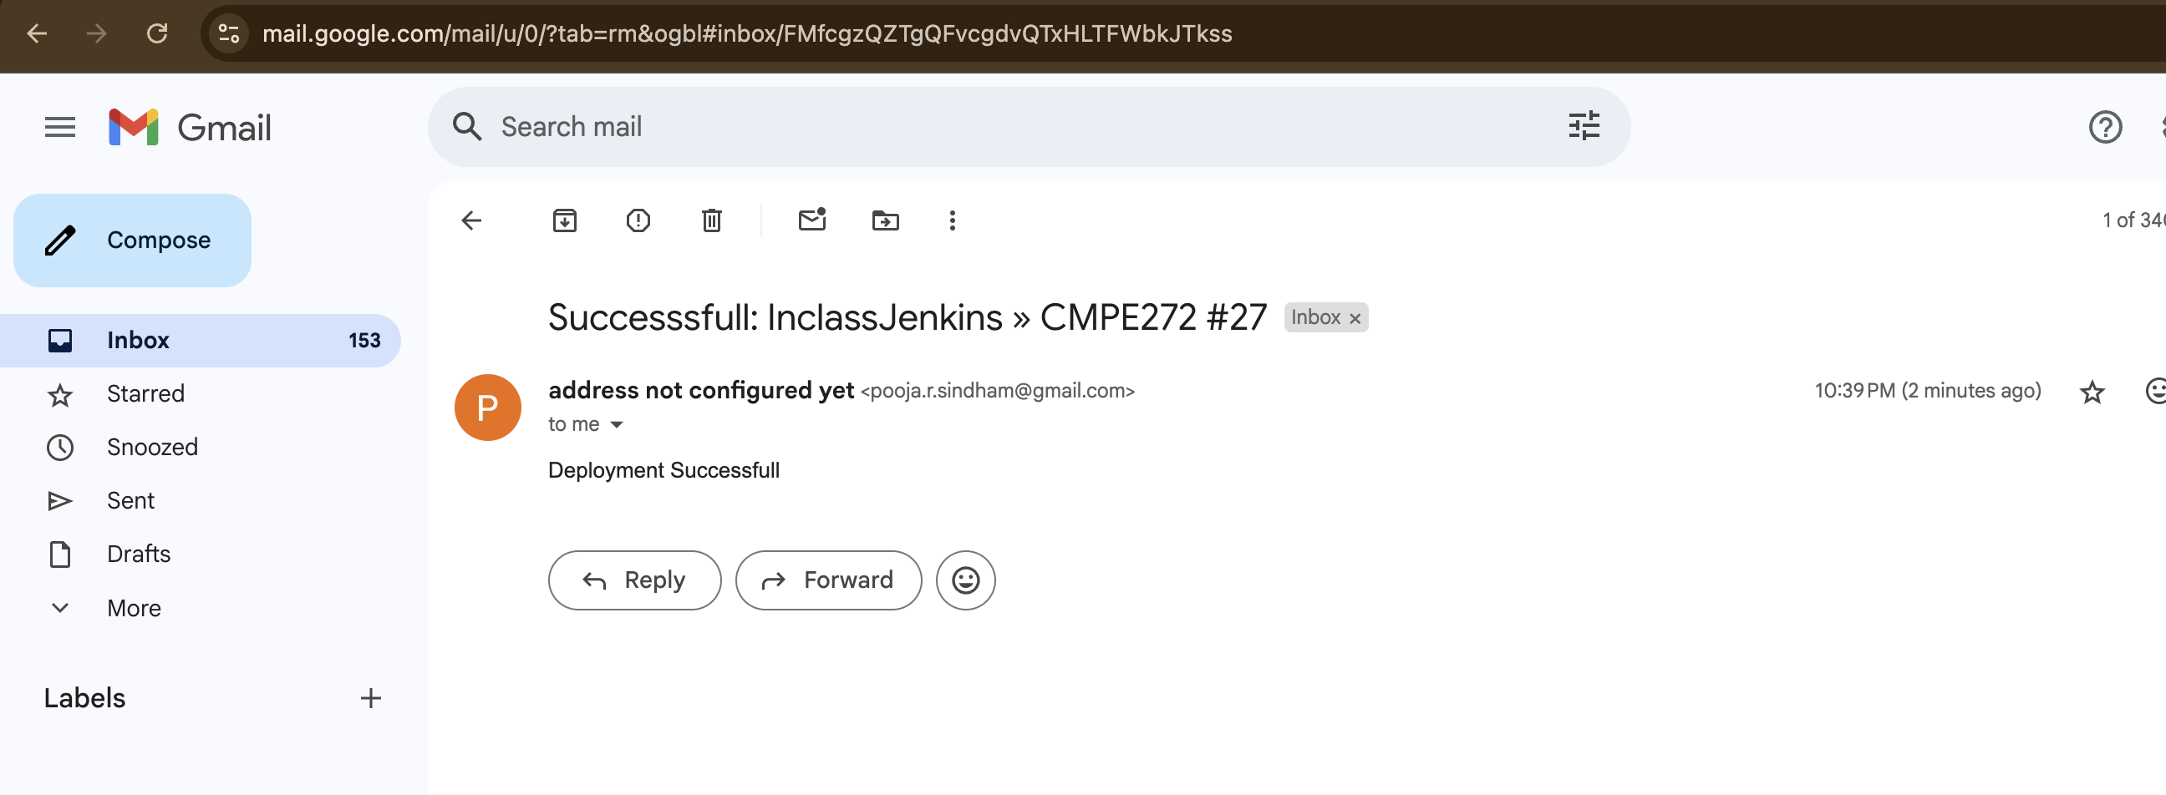

Deployment successful

